Tabulation programs:

cansum:

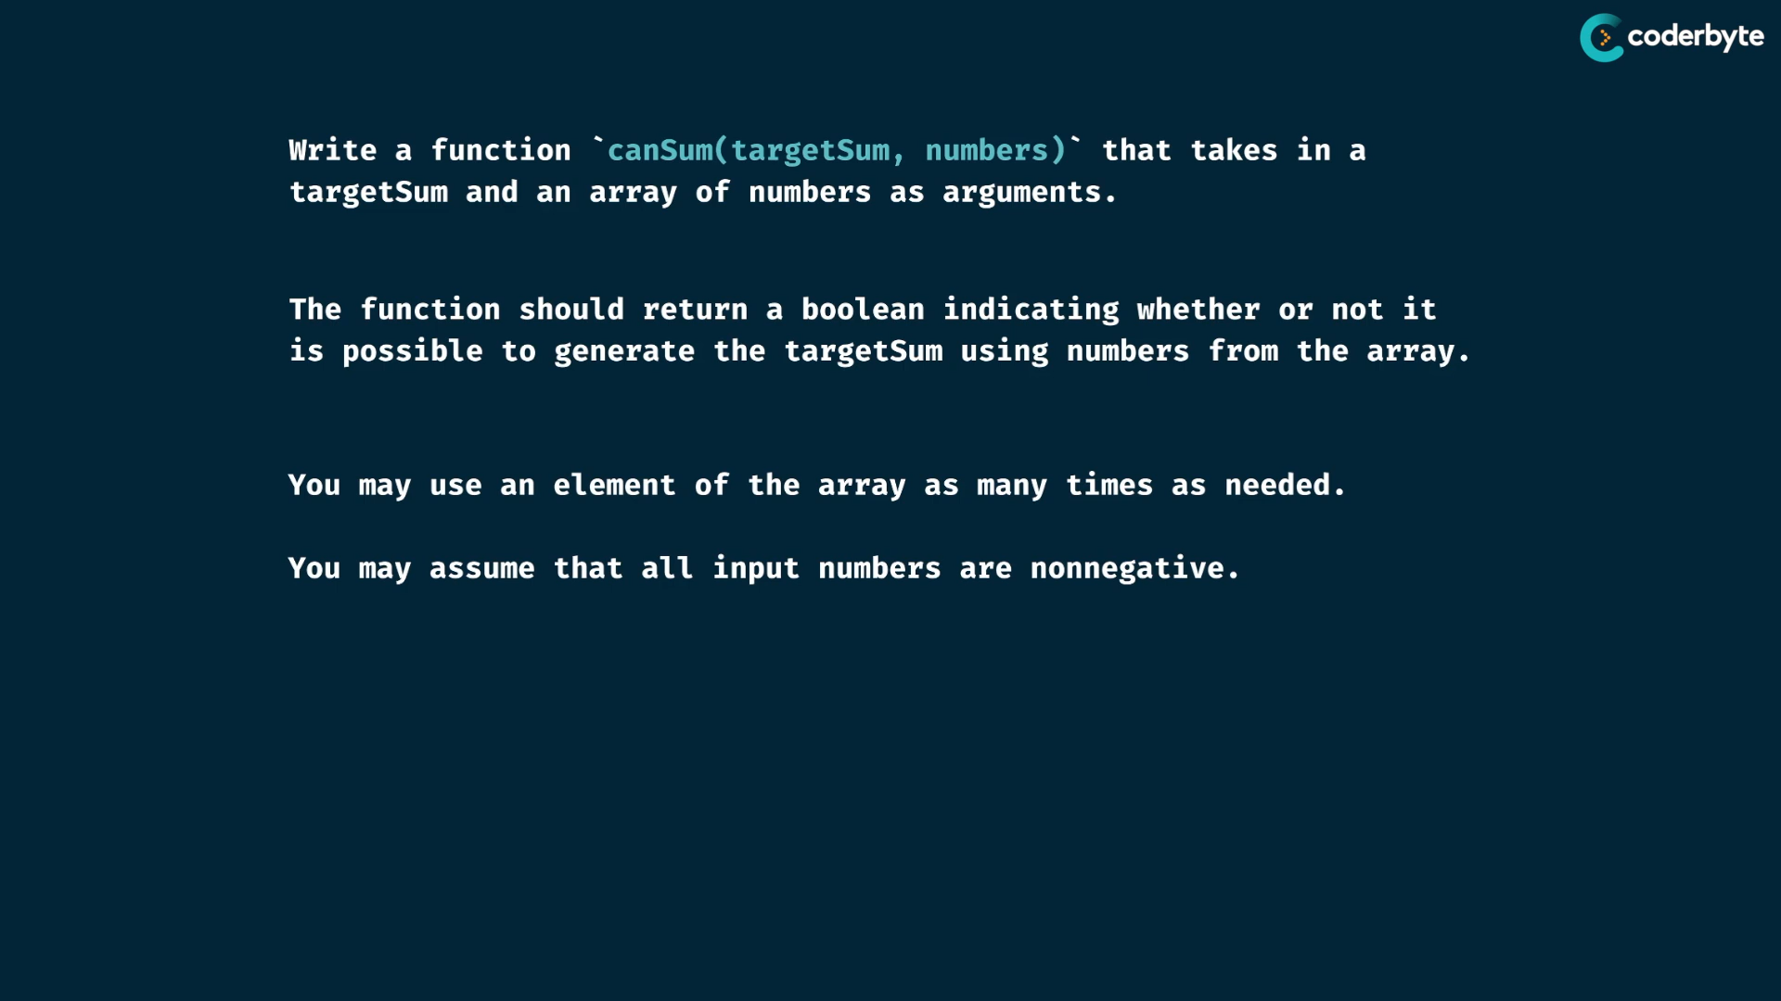

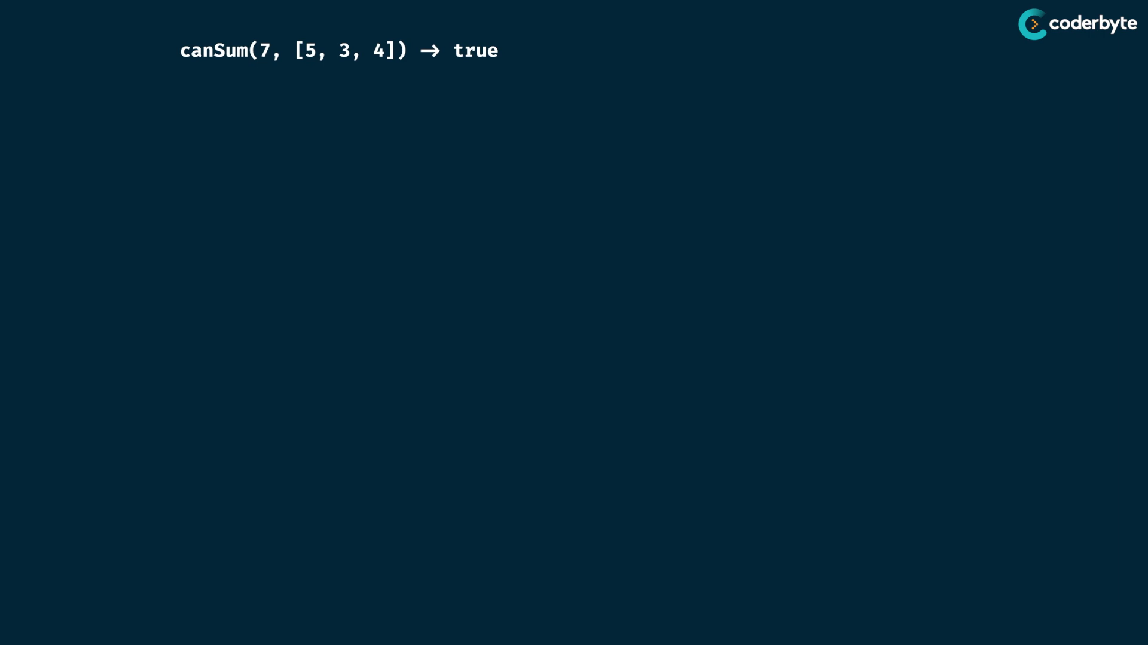

tabulation -> so think that we area using table..

what to use table… that one that varies are used in tables..

reuse numbers of array , no like shrinking size , so it does not varies ..

target number, target number is increase to the overtime.. , so it varies , so this value is stored in table …

creation is done at size of targetsum +1

we need bool answer , so we can store Boolean values in table..

intilize evey values are false ..

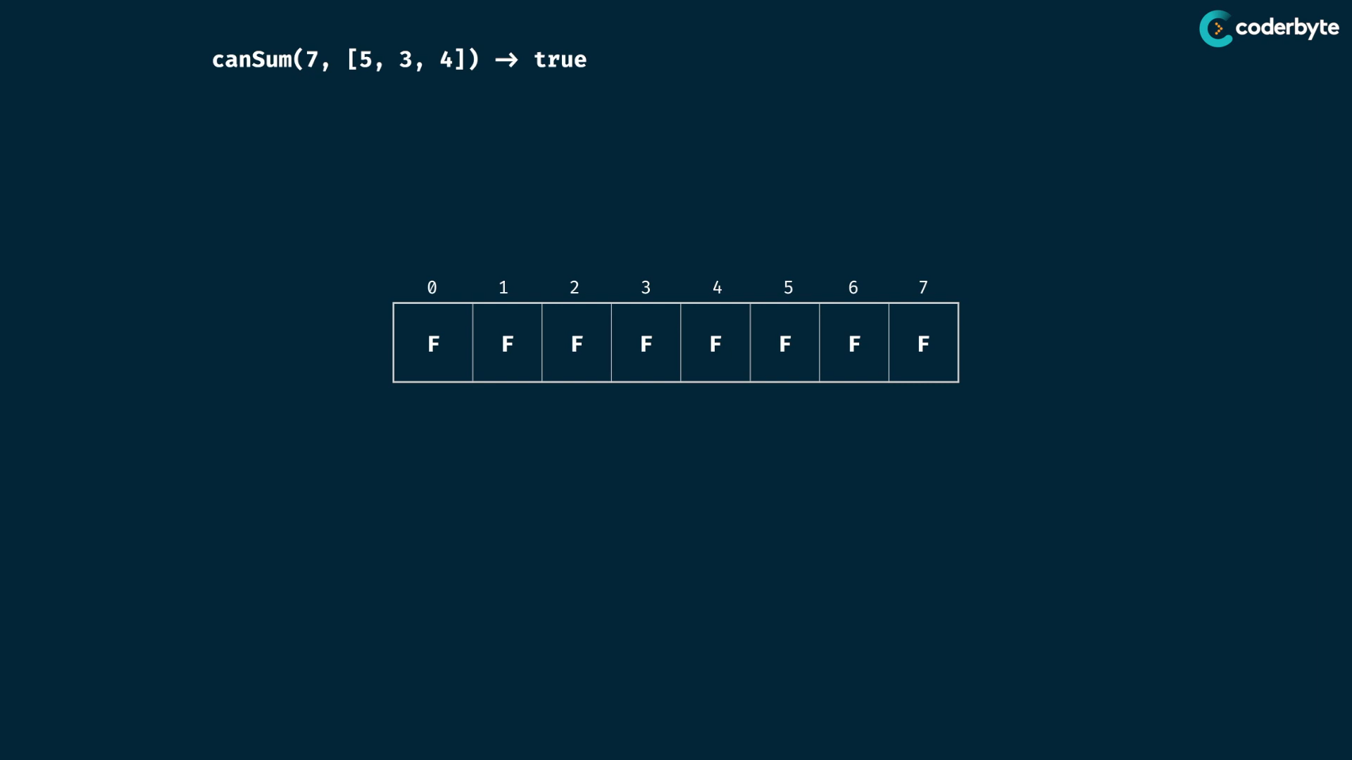

seed value of targetSum (0 ) is true , since its always possible ..

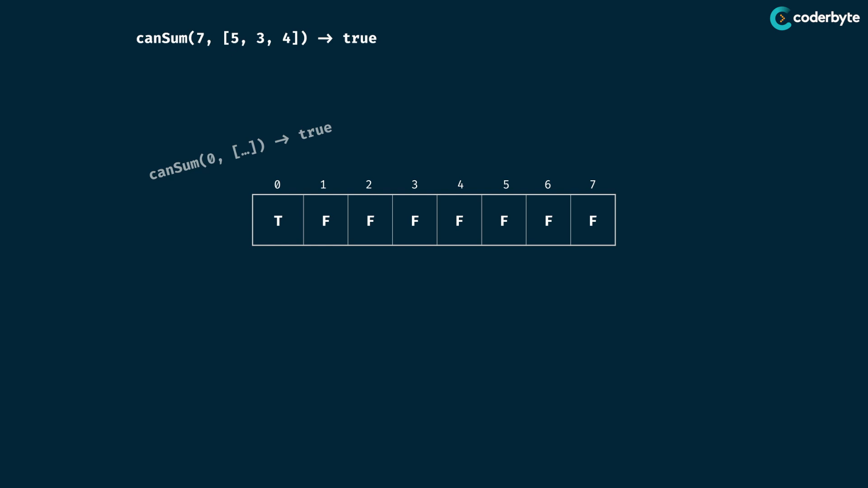

at each index, we transition into further position by considering all possible values…

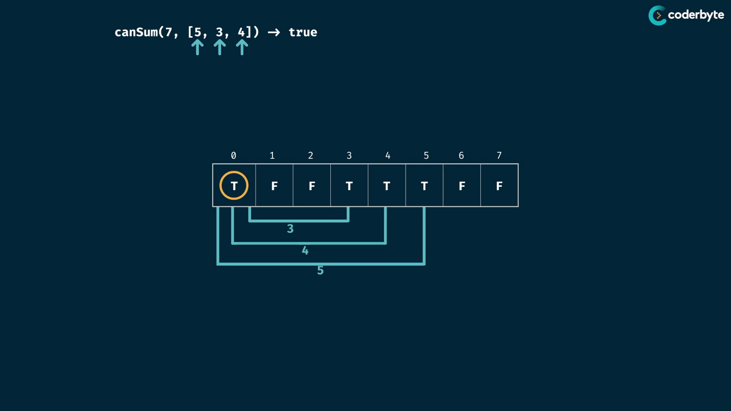

second element and third element is false , so no need the transition…

drop the out of bounds ones transitions…

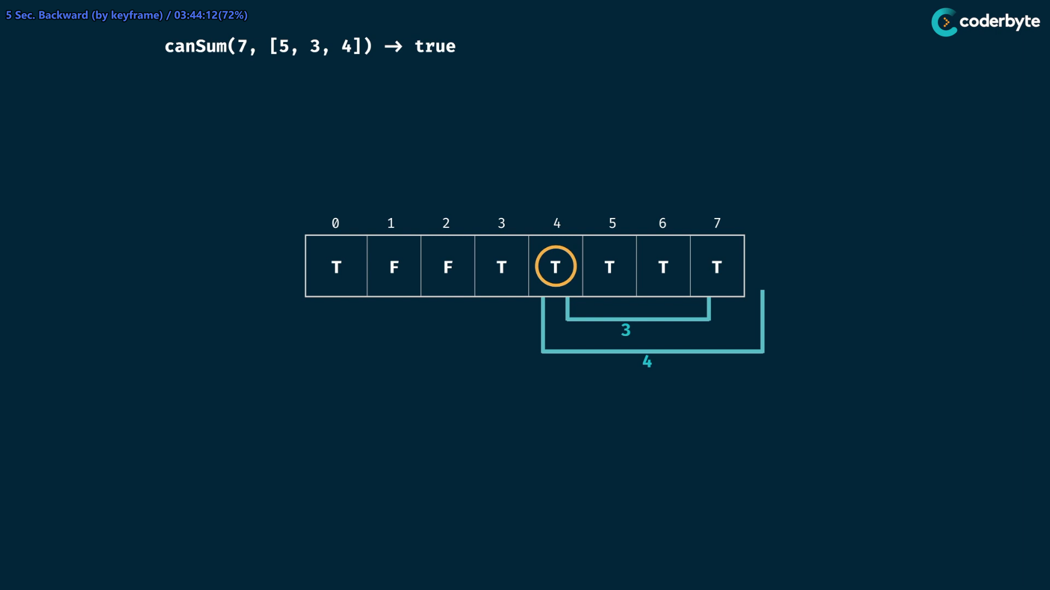

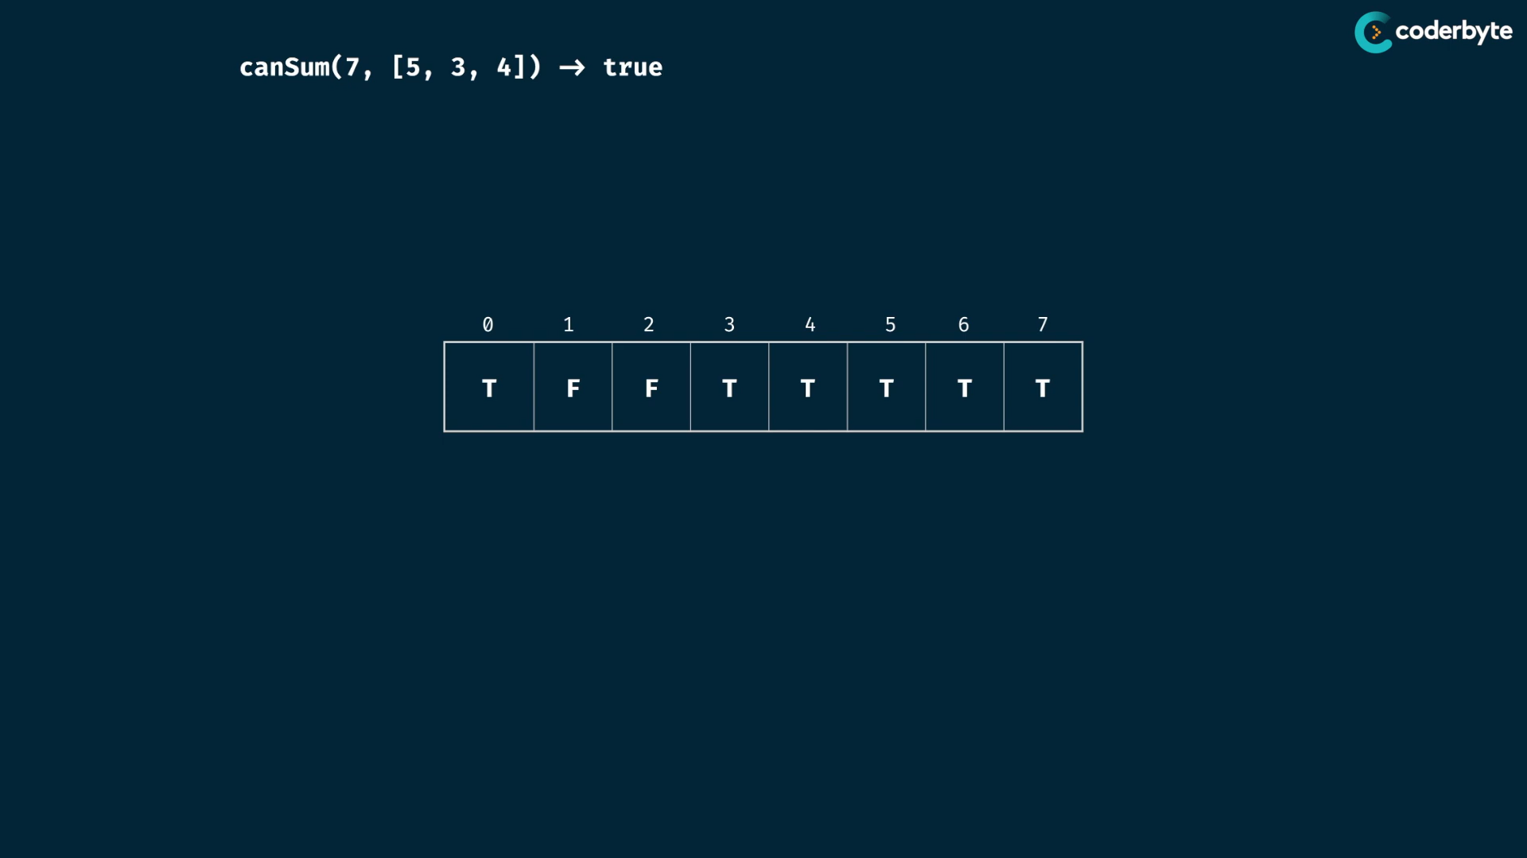

atlast true values index are possible and false values index are not possible./.

here index value repr. the target sum, so last target sum value is the prog. output…

cmplx:

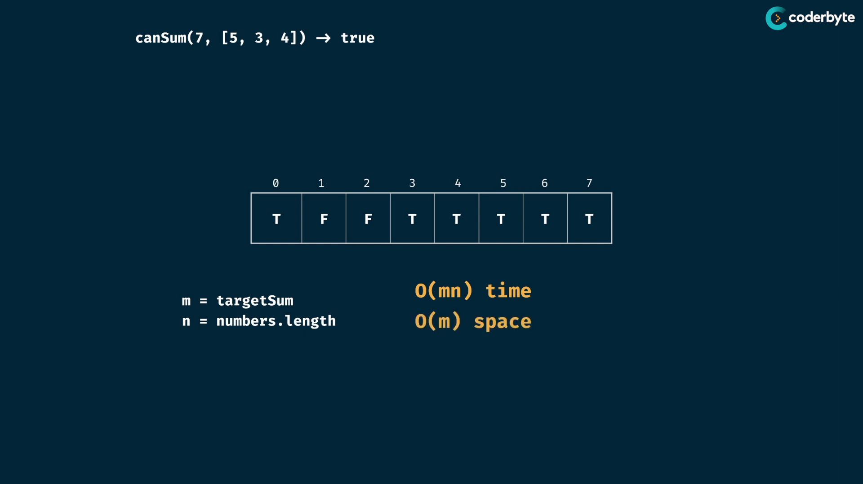

space is the target sum value size at worst case only 1 in array ..

time is the looping all combinations of 2 loops ..[at worst case of all True values .]

code:

//+ canSum (tab)

const canSum = (targetSum, numbers) => {

    let table = Array(targetSum+1).fill(false);

    table[0] = true;

    for(let i=0;i<targetSum;i++){

        if(table[i] == true){

            for(let num of numbers){

                // note: managing out of index is not needed in js

                table[i+num] = true;

            }

        }

    }

    return table[targetSum];

};

console.log(canSum(7,[2,3]))     //=> true

console.log(canSum(7,[5,3,4,7])) //=> true

console.log(canSum(7,[2,4]))     //=> false

console.log(canSum(8,[2,3,5]))   //=> true

console.log(canSum(300,[7,14]))  //=> false

howsum prob:

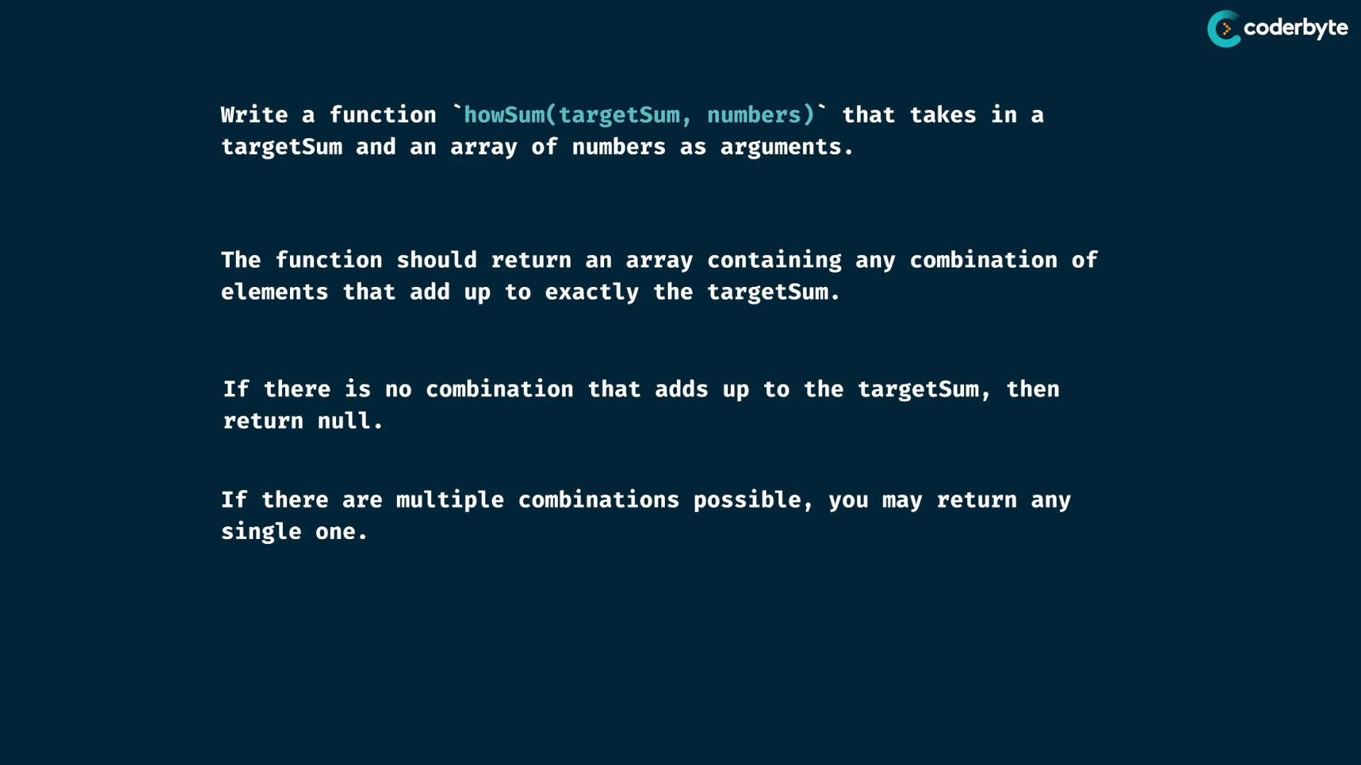

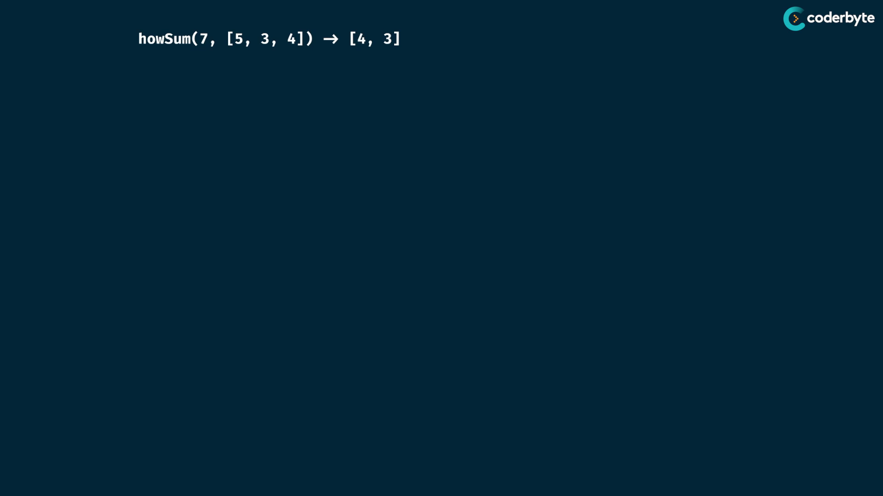

see at 0 index is []

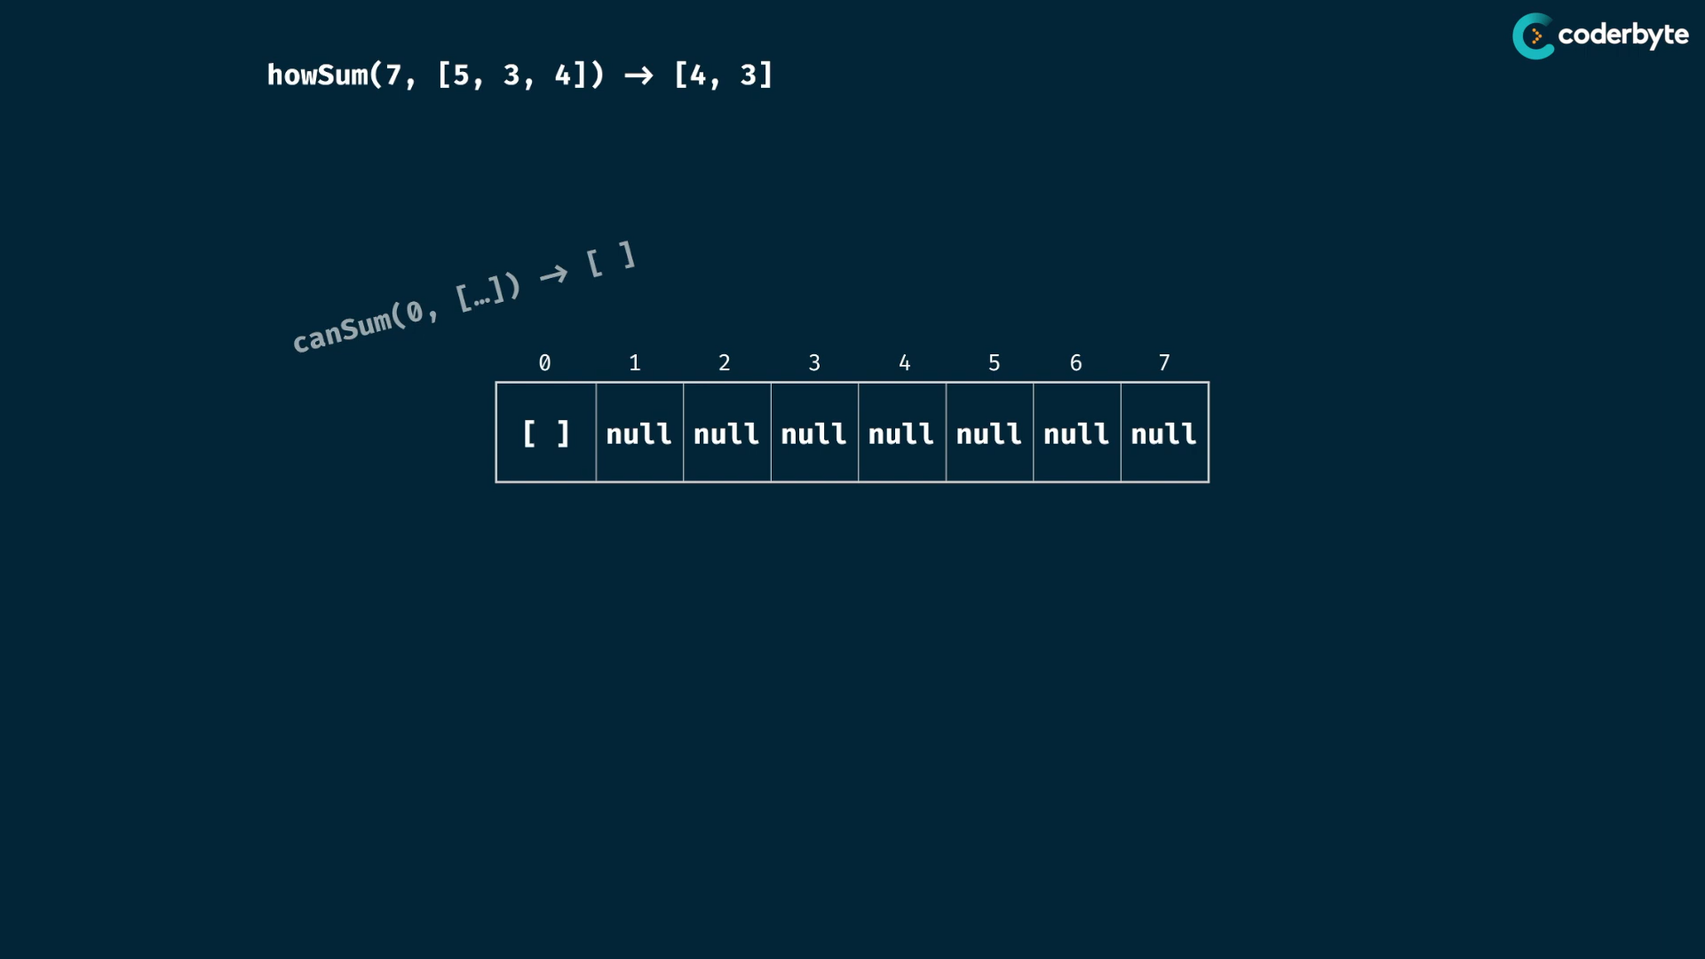

here we add up to the values of index that we reaching …

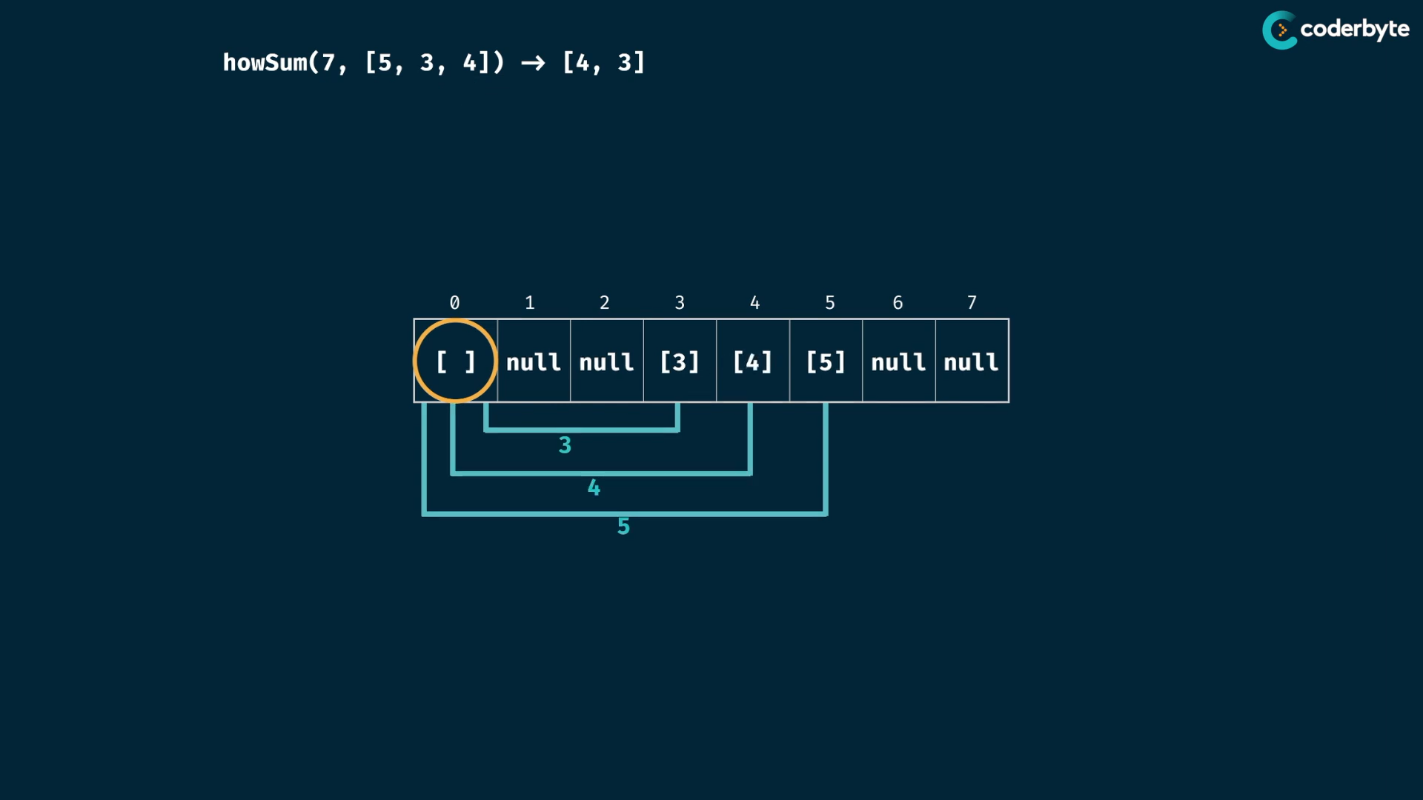

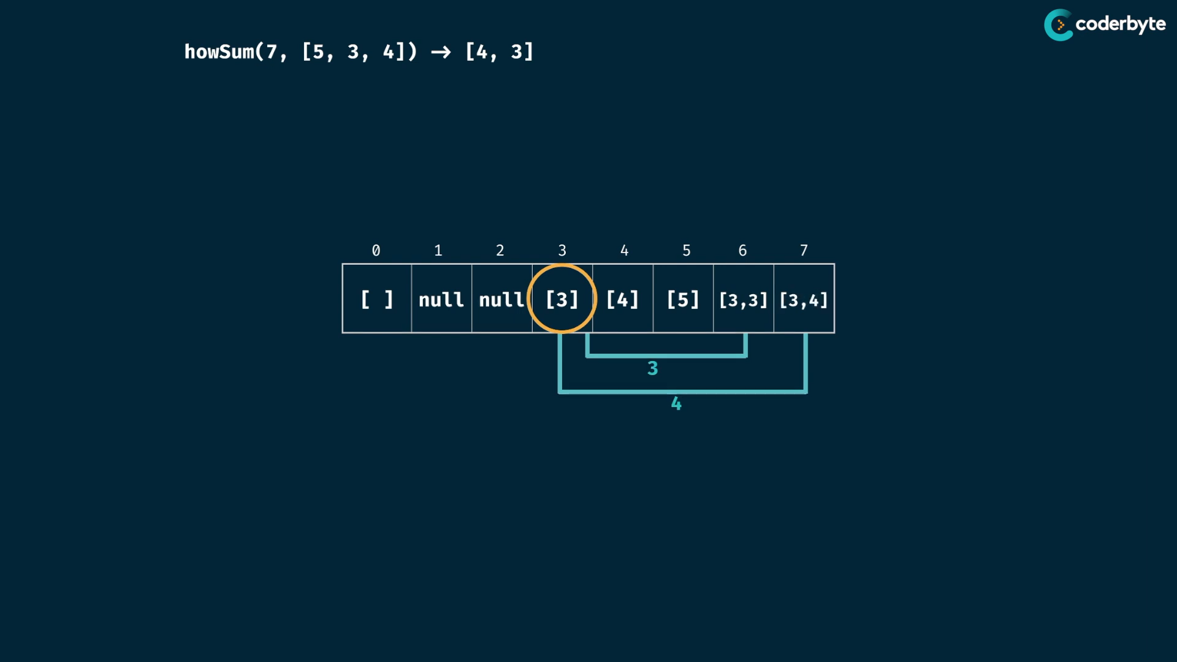

do overwriting

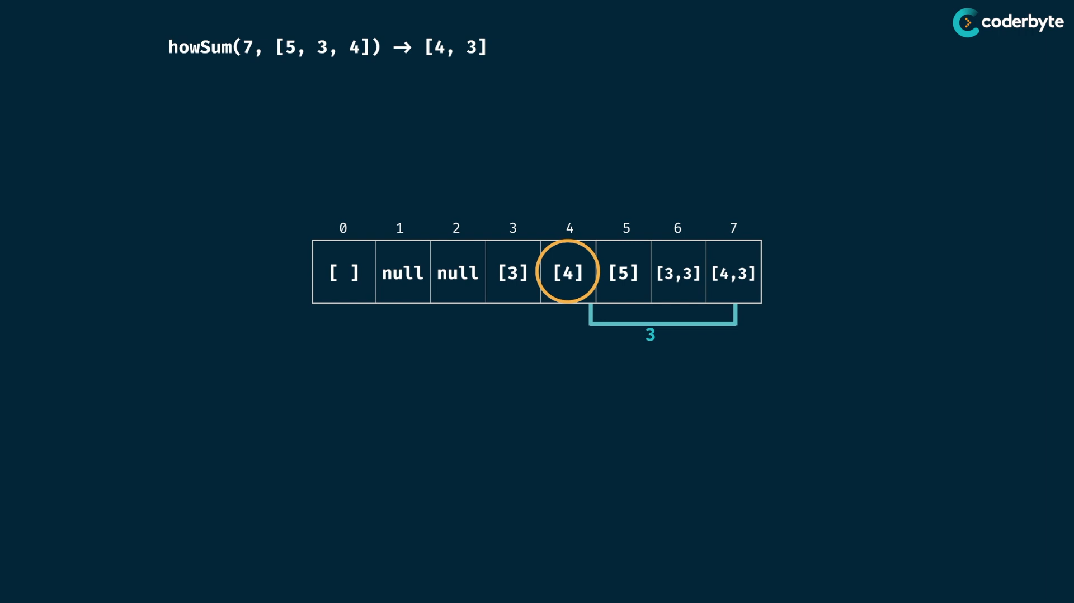

element at index 7 is valid ans

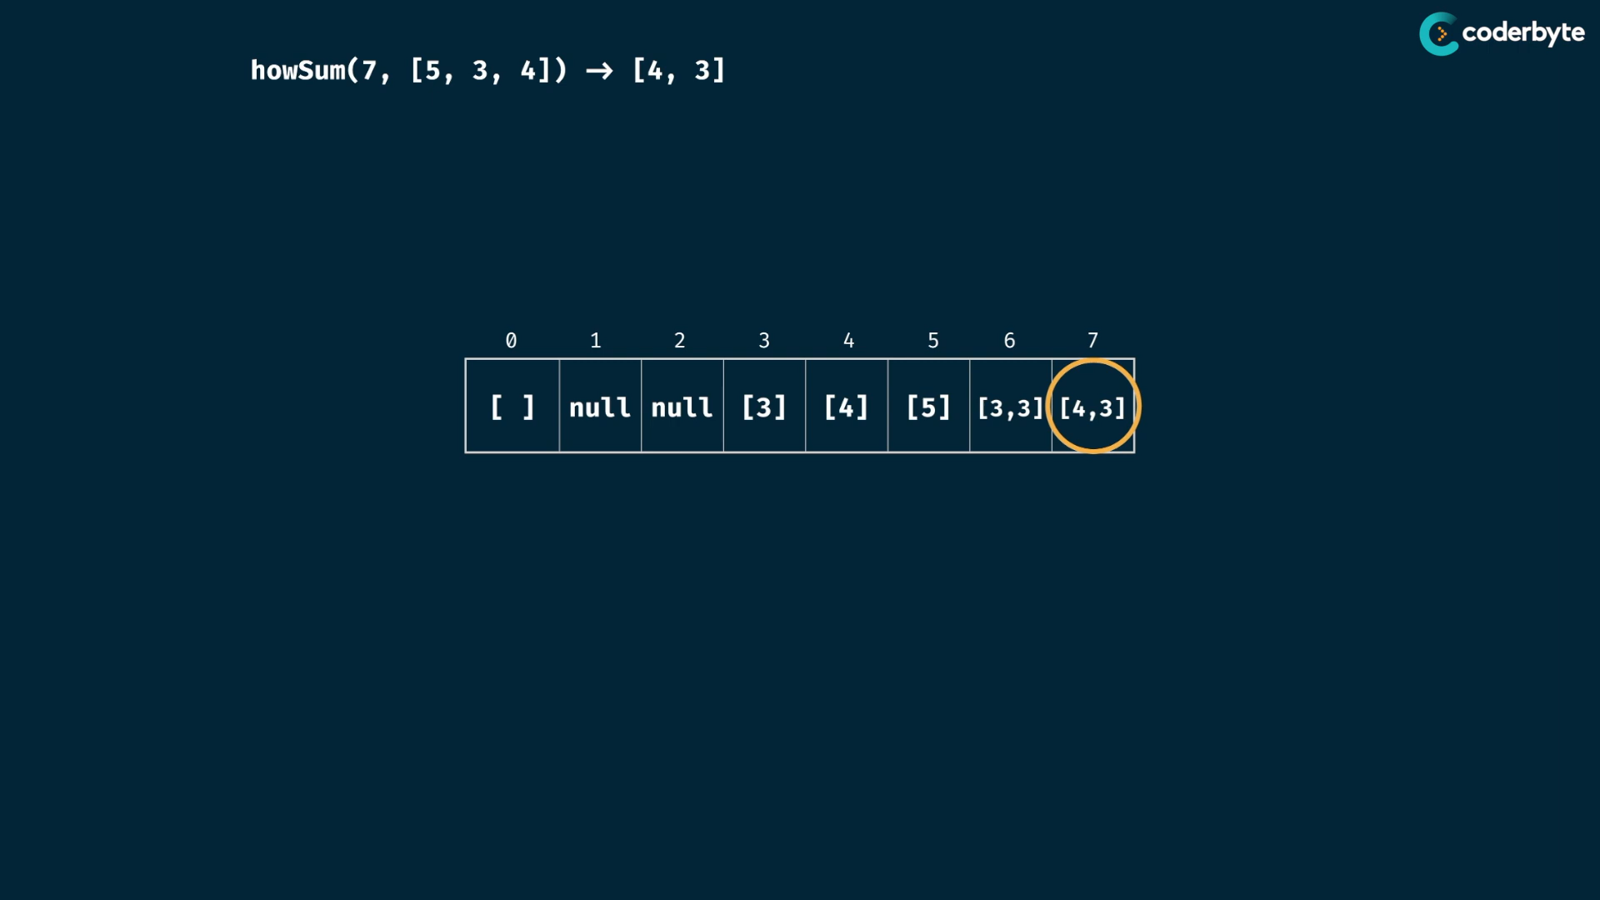

cmplx:

m = target sum

n = numbers length

time:

* iterate through the table , so m
* for every element in iteration , we also iterate through numbers array .. so n for every m
* copy over of current position array to destination , current array length is atmost length of targetsum at worst of 1 for m times… so we add up m to every iteration.. .. at worst case every time overwriting is done..

so we conclude that O(m*n*m)

space:

* size of array of target sum , m
* each element of array can have array of combinations upto m values at most, so m

so we conclude that O(m*m)

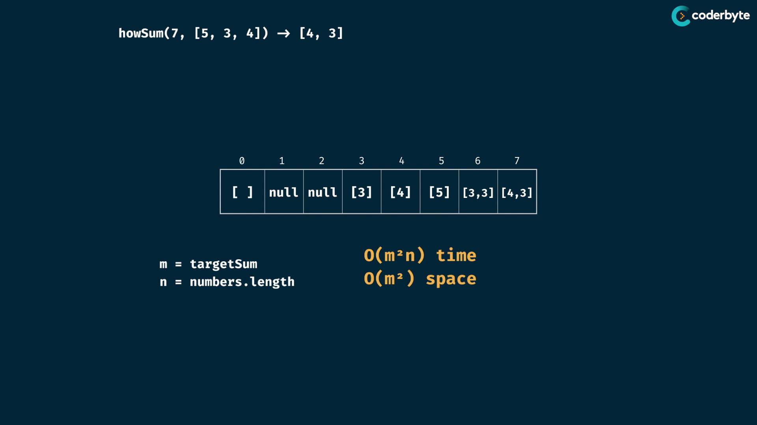

so cmplx. are exponentials ..

code:

//+ howSum (tab)

const howSum = (targetSum, numbers) => {

    let table = Array(targetSum+1).fill(null);

    table[0] = [];

    for(let i=0;i<targetSum;i++){

        if(table[i] !== null){

            for(let num of numbers){

                  table[i+num] = [...table[i],num];

            }

        }

    }

    return table[targetSum];

};

console.log(howSum(7,[2,3]))     //=> [3,2,2]

console.log(howSum(7,[5,3,4,7])) //=> [4,3]

console.log(howSum(7,[2,4]))     //=> null

console.log(howSum(8,[2,3,5]))   //=> [2,2,2,2]

console.log(howSum(8,[3,5,2]))   //=> [2,2,2,2]

console.log(howSum(300,[7,14]))  //=> null

bestSum:

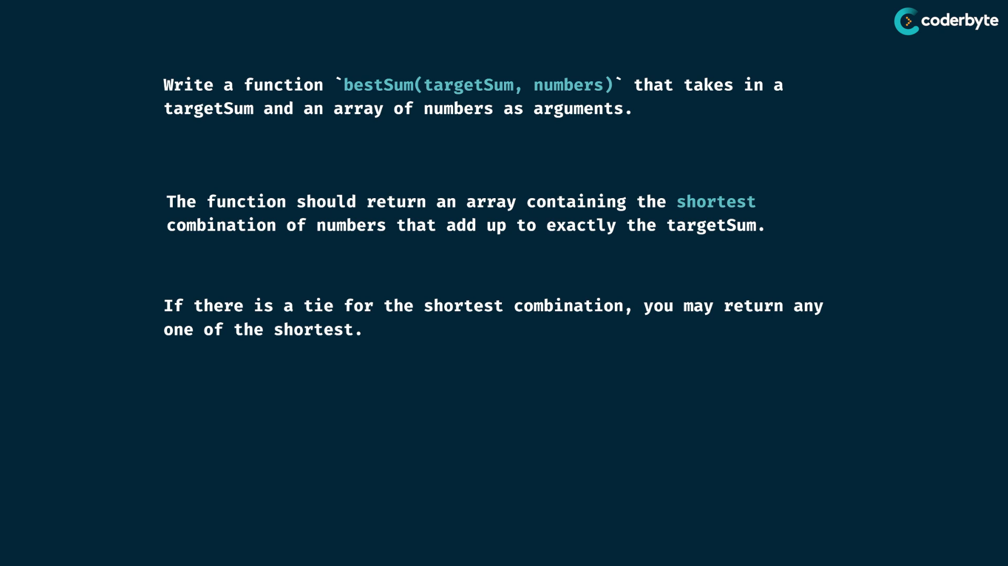

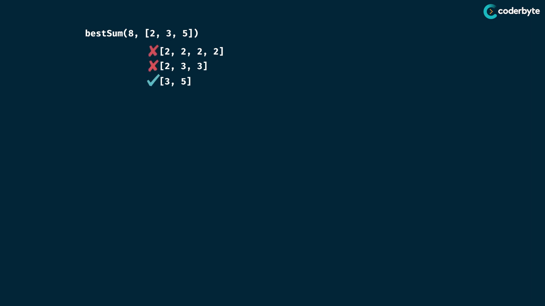

solving:

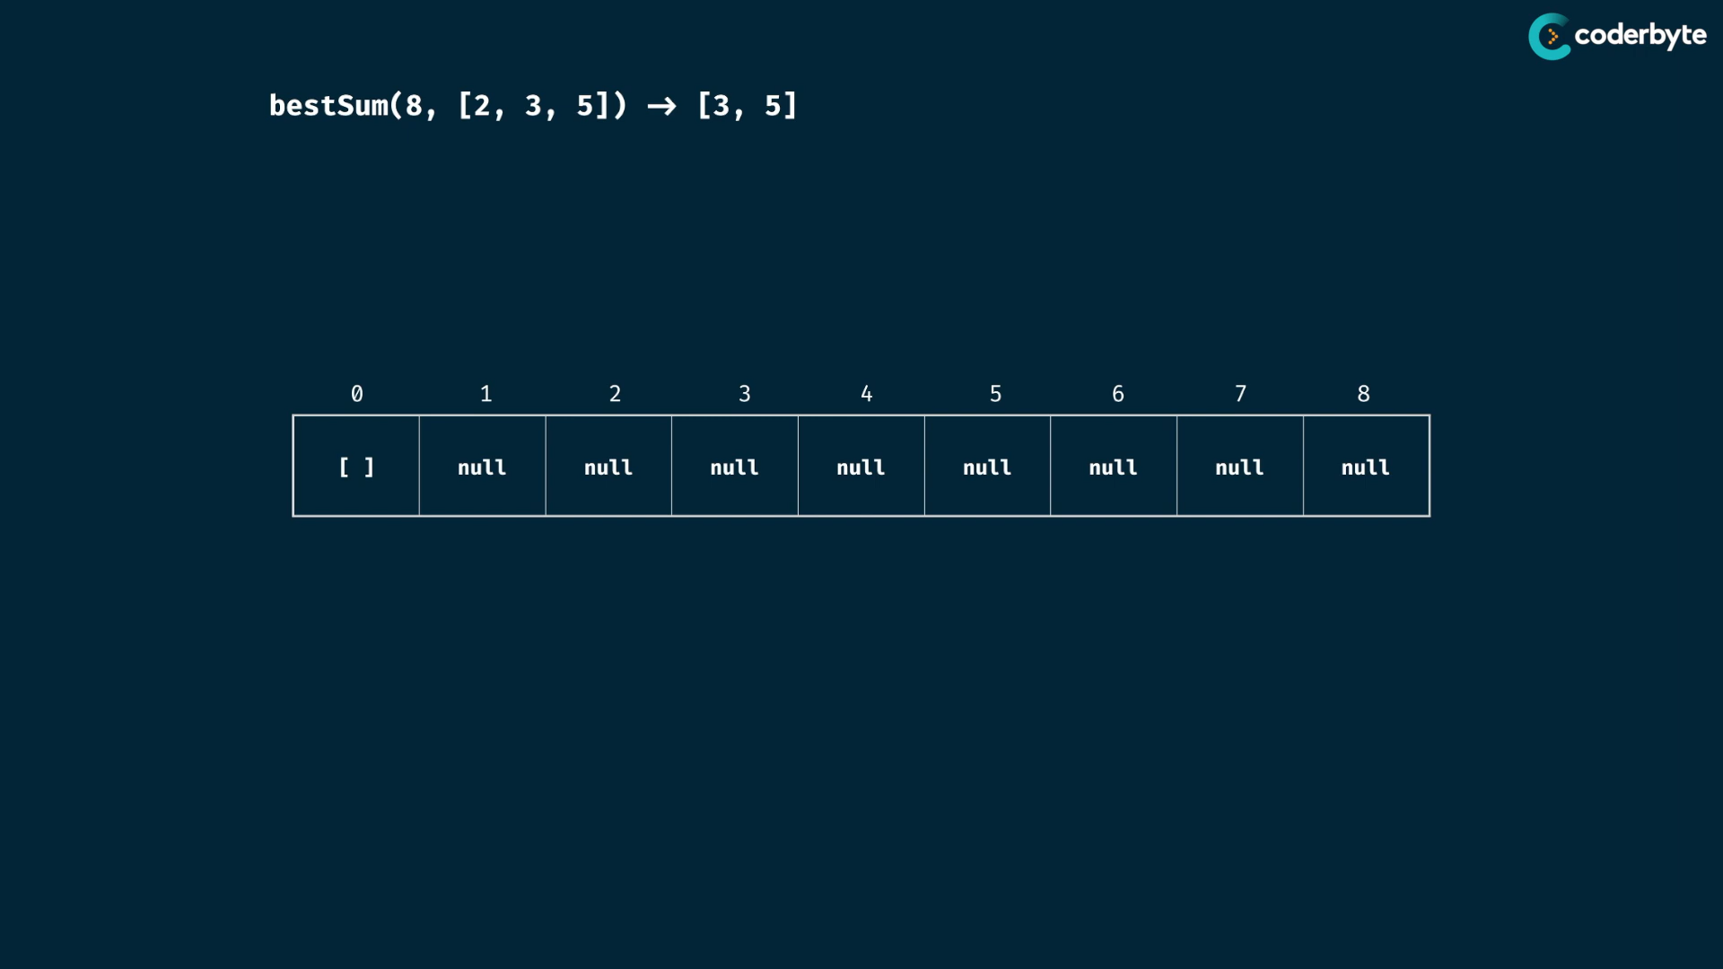

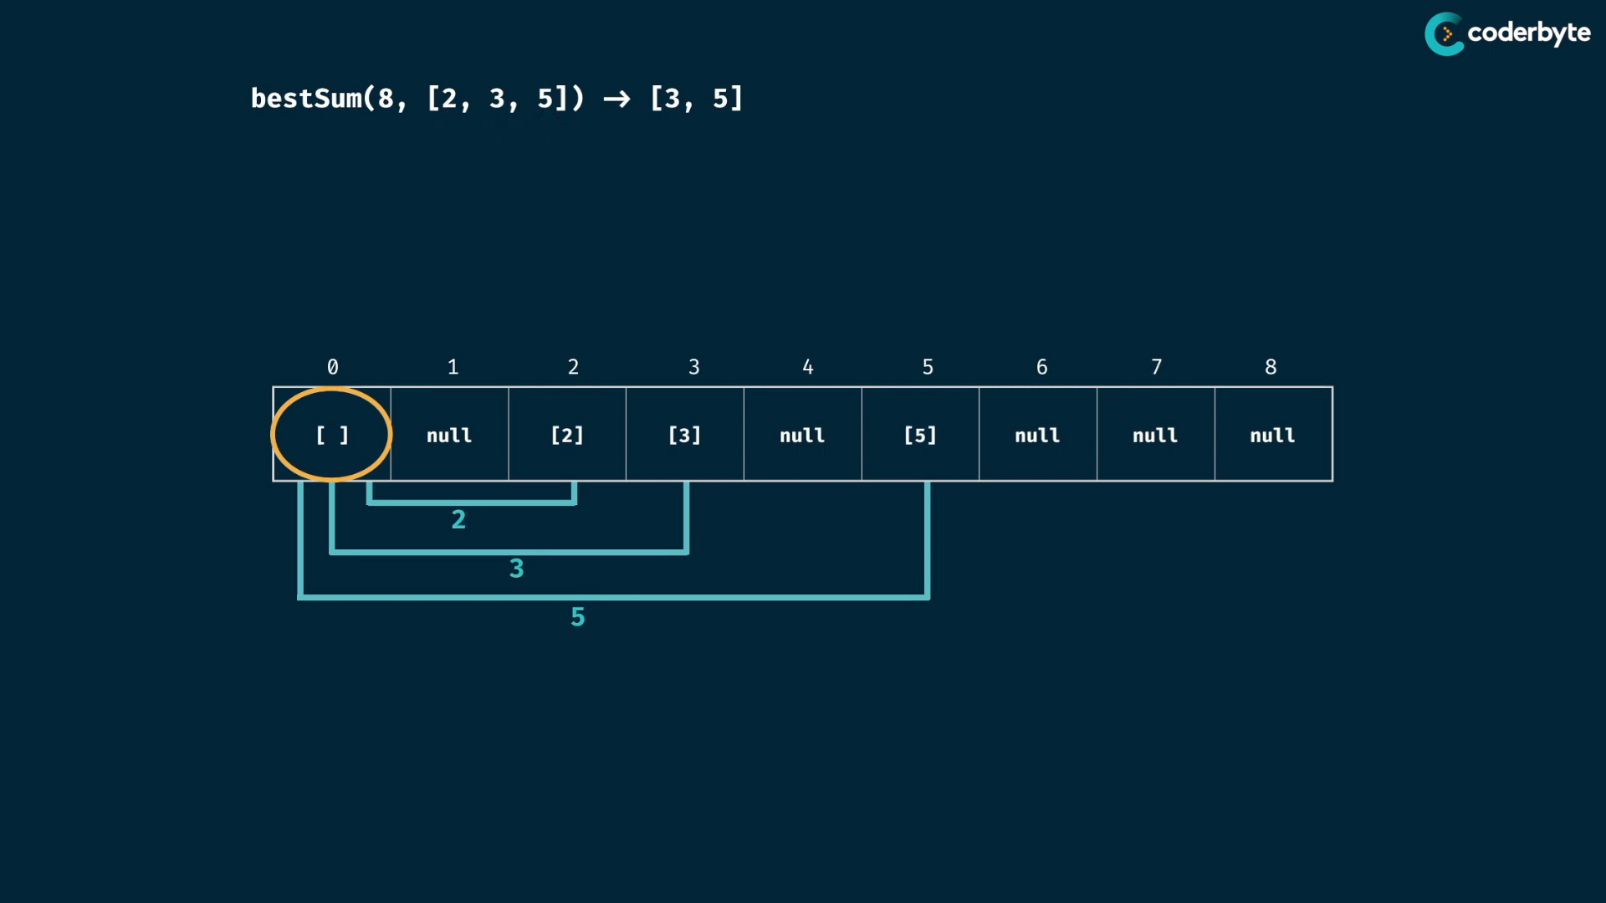

overwriting is done only when new one’s length is lesser than old length ..

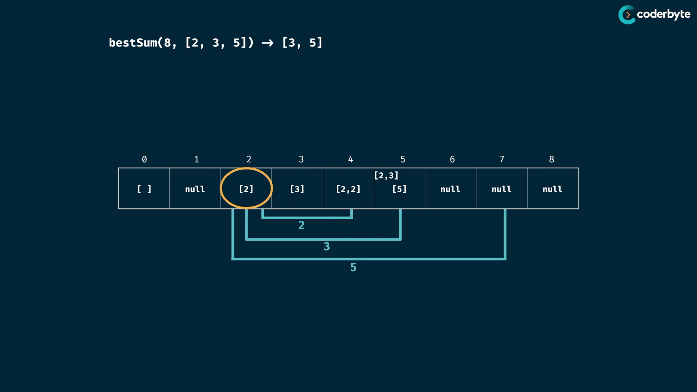

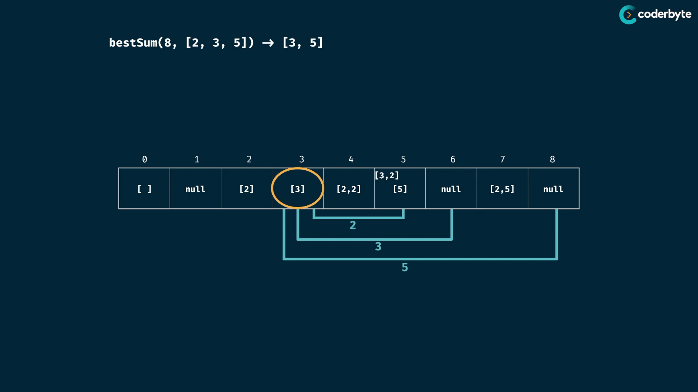

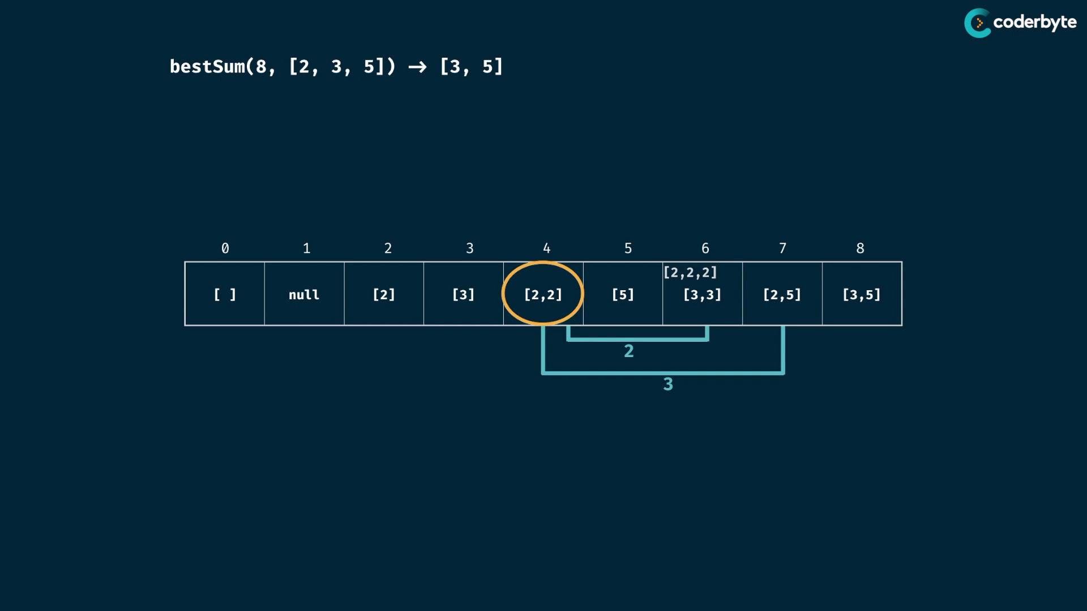

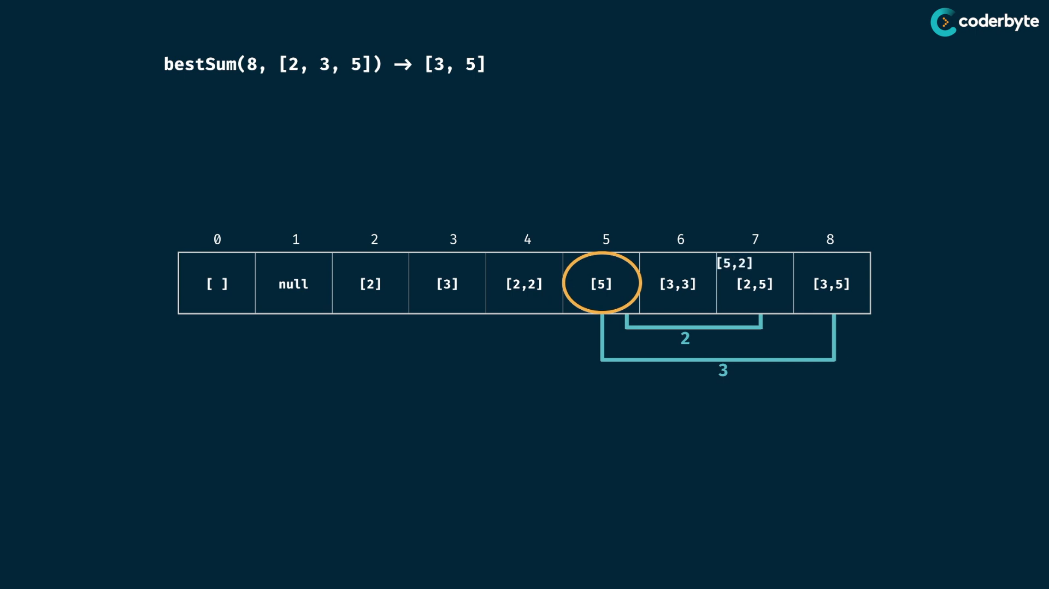

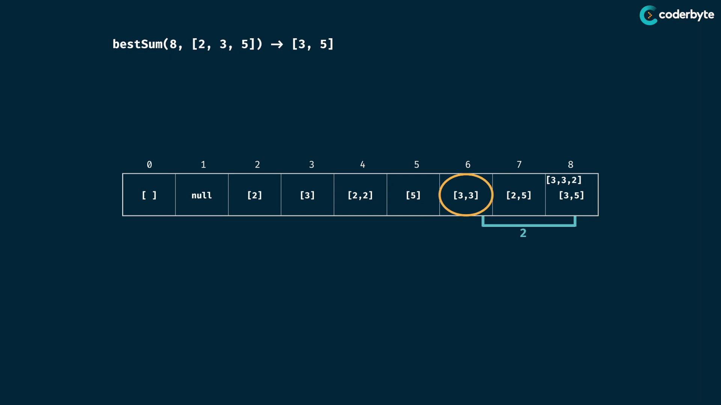

cmplx:

like same as last prob..

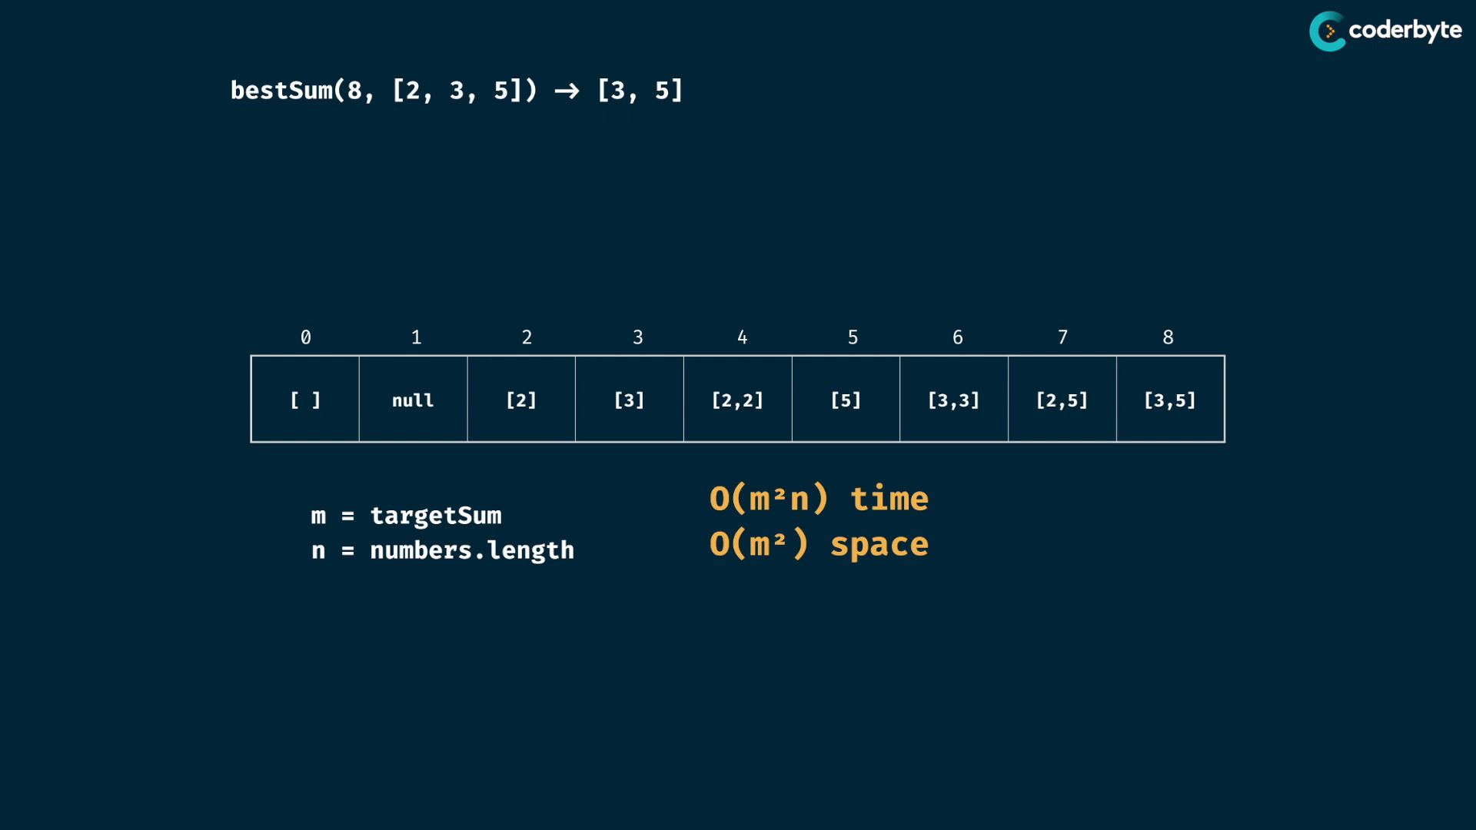

code:

*//+ bestSum (tab)*

const bestSum = (targetSum, numbers) => {

  let table = Array(targetSum+1).fill(null);

  table[0] = [];

  for(let i=0;i<targetSum;i++){

      if(table[i] !== null){

          for(let num of numbers){

                  const combination = [...table[i],num];

*// managing null & undefined falsy values and shorter ones*

                  if(!table[num+i] || ( combination.length < table[num+i].length)){

                      table[num+i] = combination;

                  }

          }

      }

  }

  return table[targetSum];

};

console.log(bestSum(7,[2,3]))     *//=> [2,2,3]*

console.log(bestSum(7,[5,3,4,7])) *//=> [7]*

console.log(bestSum(7,[2,4]))     *//=> null*

console.log(bestSum(8,[2,3,5]))   *//=> [3,5]*

console.log(bestSum(8,[3,5,2]))   *//=> [3,5]*

console.log(bestSum(8,[1,4,5]))   *//=> [4,4]*

console.log(bestSum(300,[7,14]))  *//=> null*

console.log(bestSum(100,[1,2,5,25]))*//=> [ 25, 25, 25, 25 ]*

**String prob:**

canConstruct:

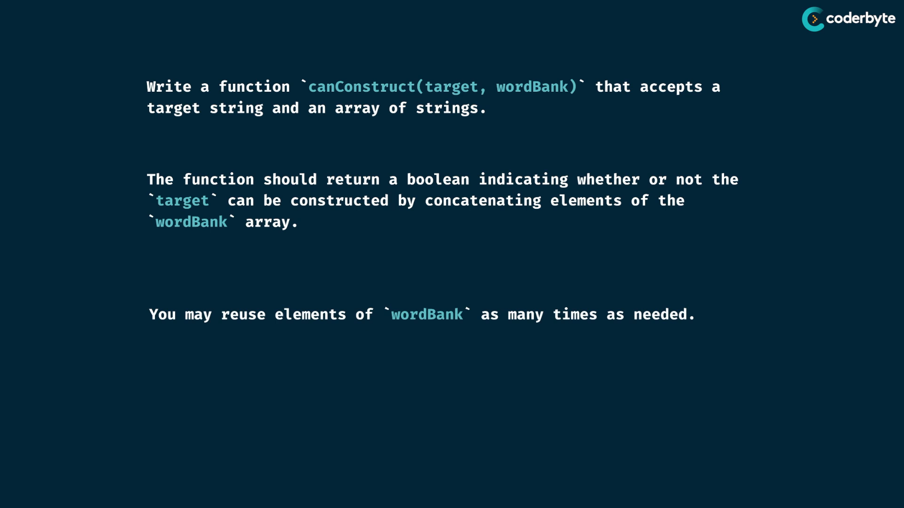

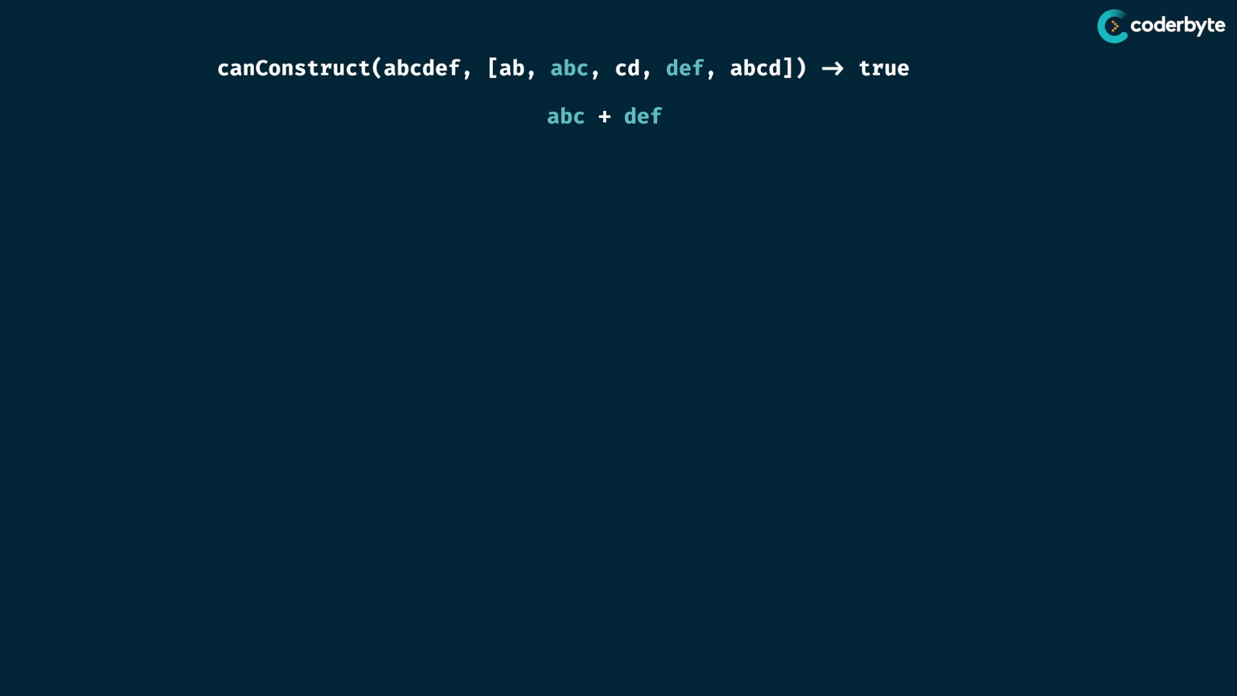

tab:

targetString only changes , not the wordbank strings…. so table is targetstring length …

in tabulation, one more space is always needed in order for extra seed case ones …

here indexes represent , upto before char of string , not including the index char …

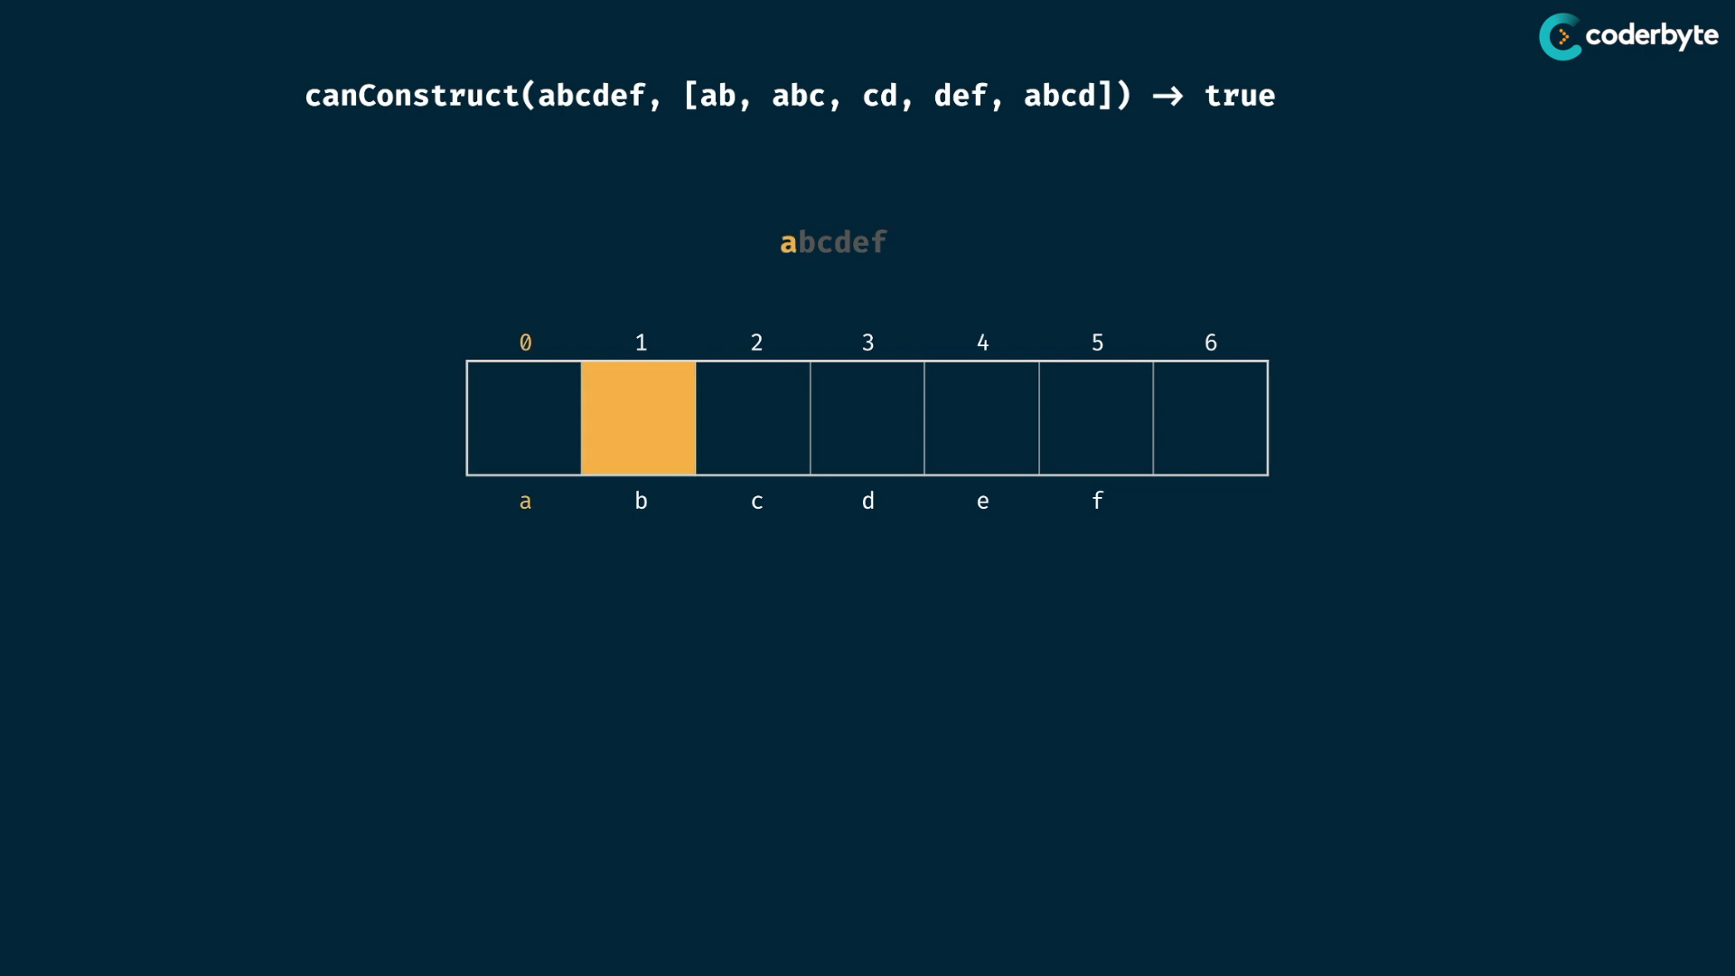

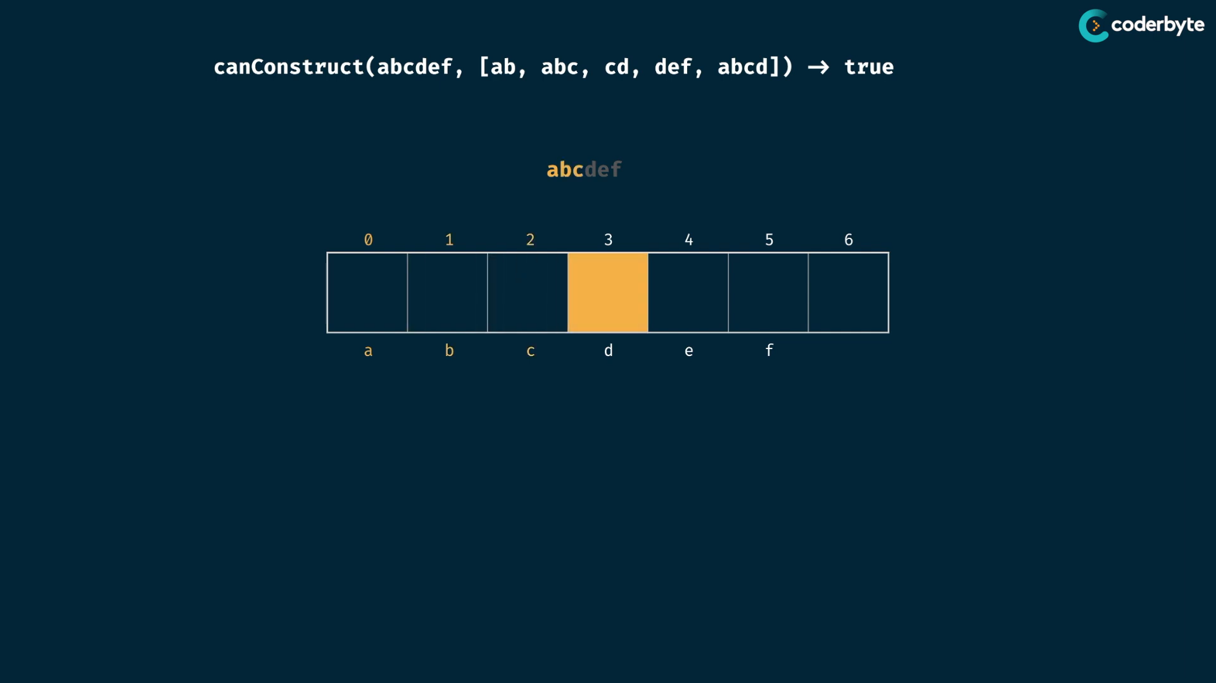

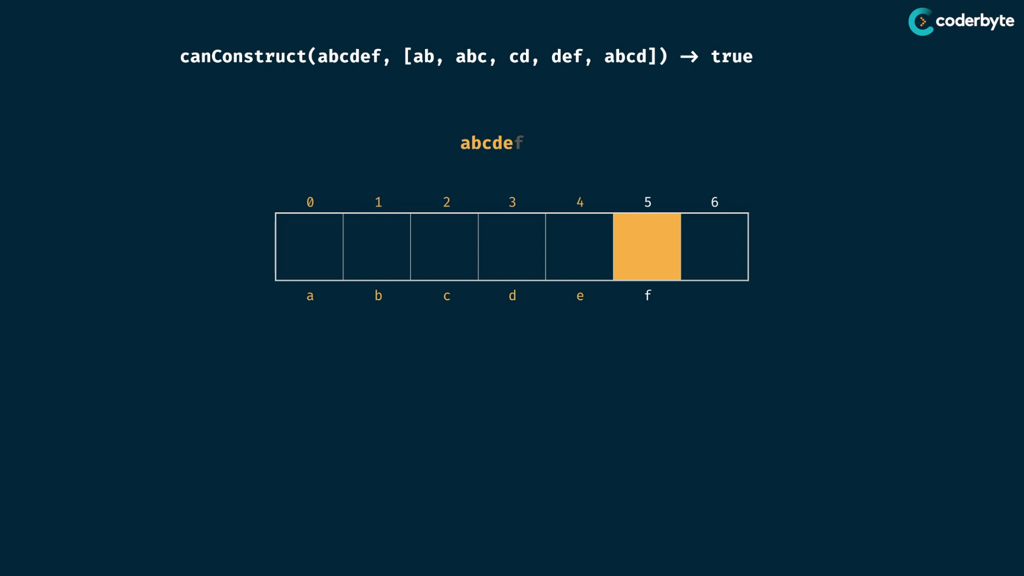

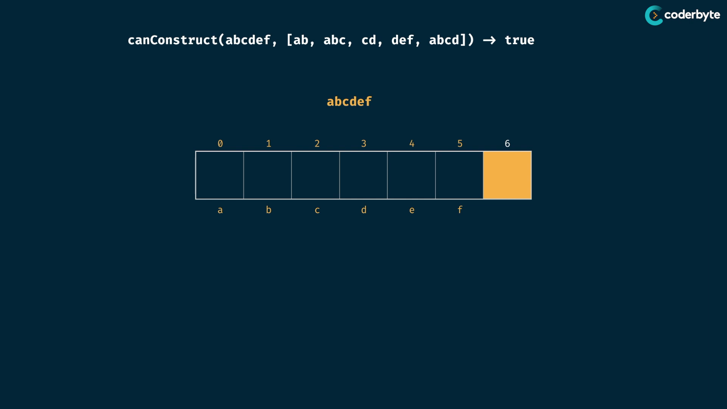

seed values :

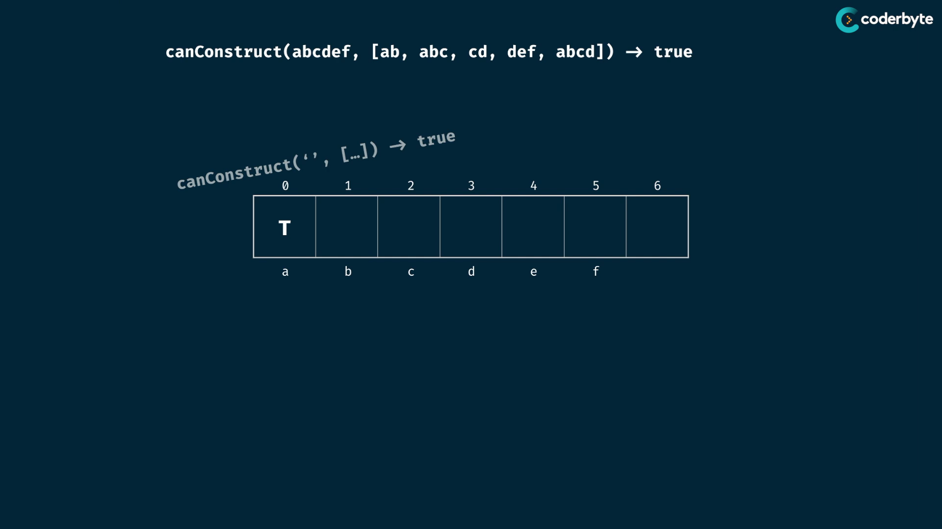

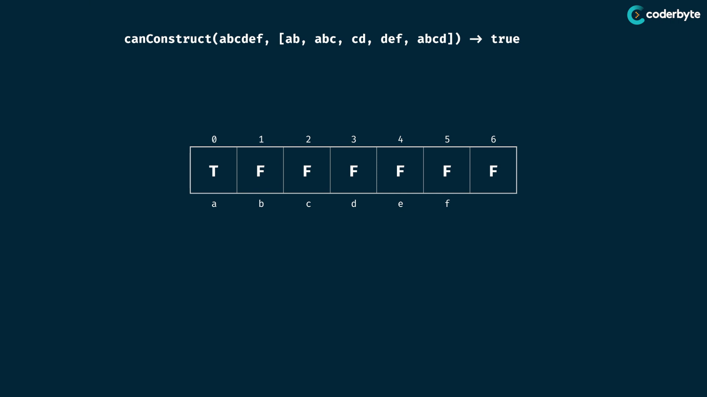

doing logics:

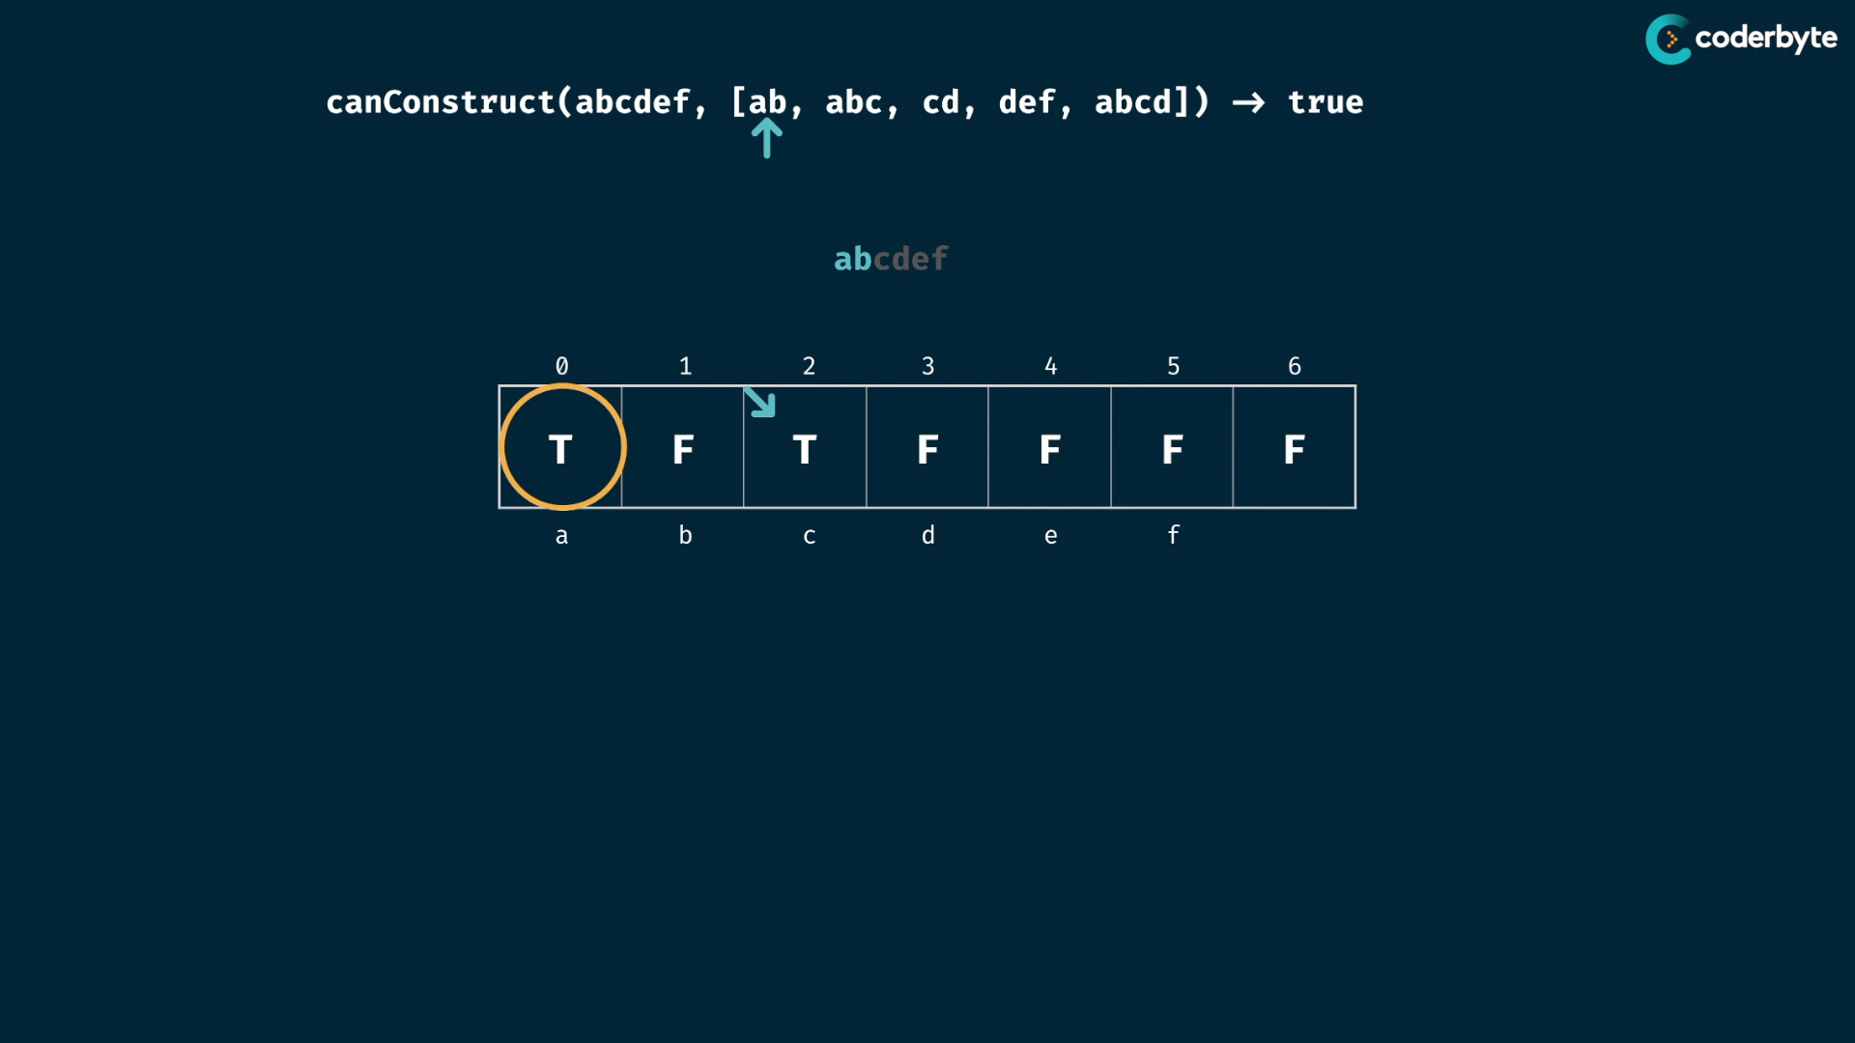

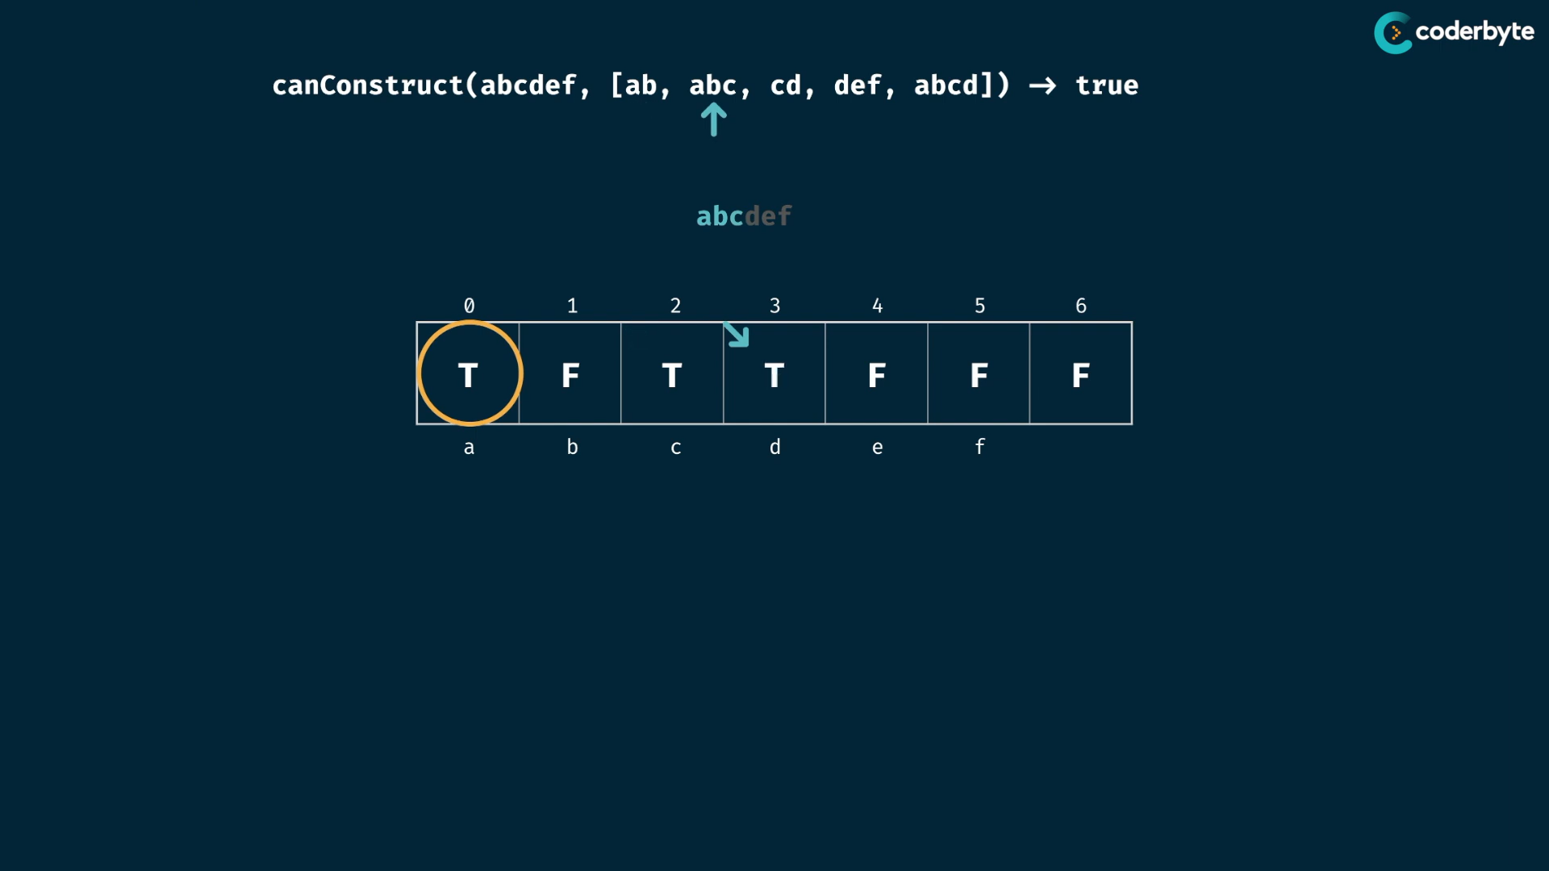

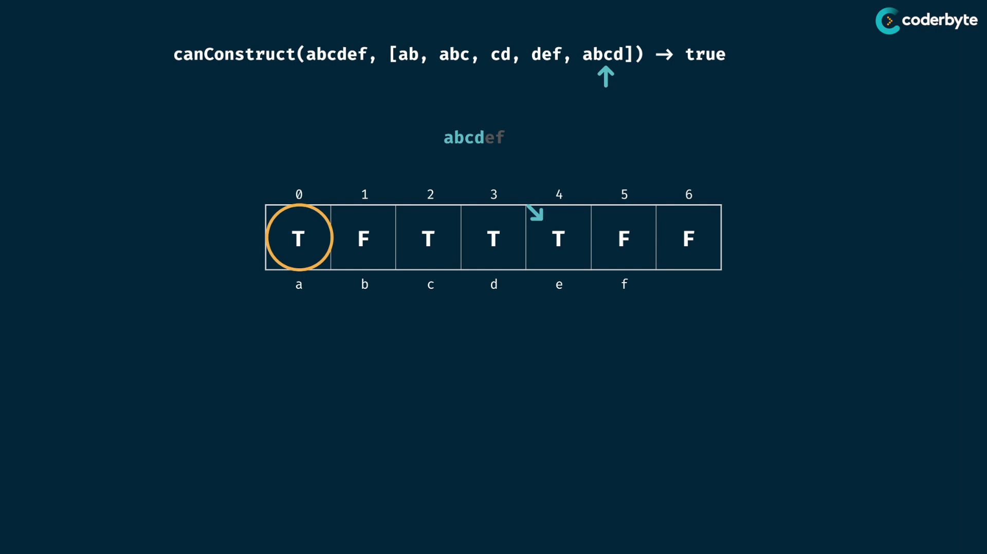

skip false values

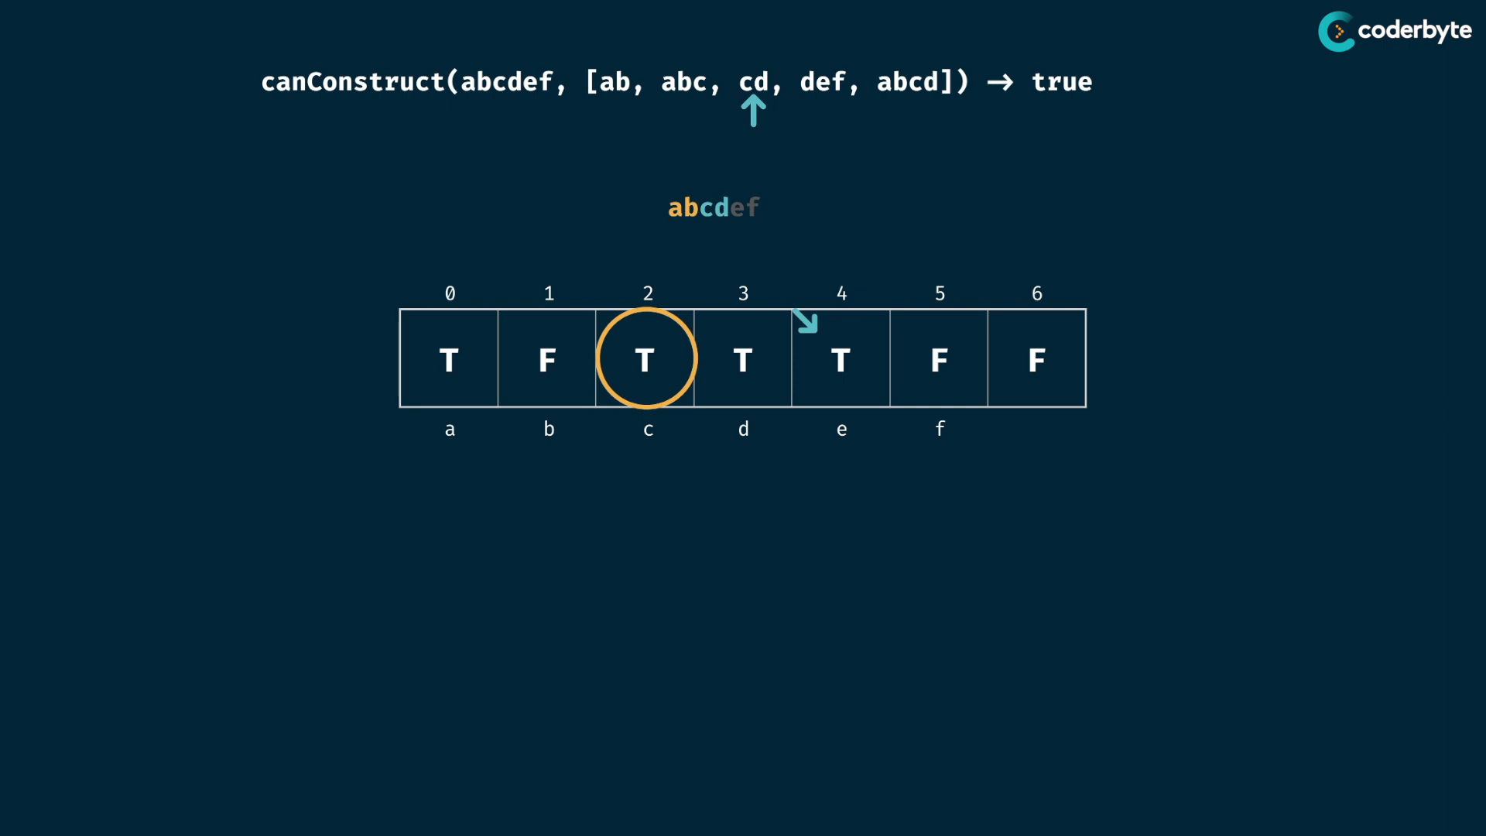

… likewise ..

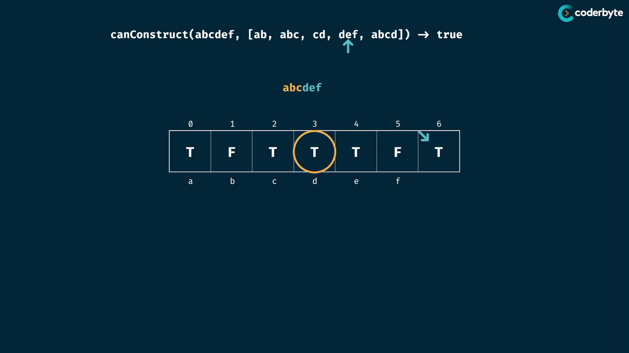

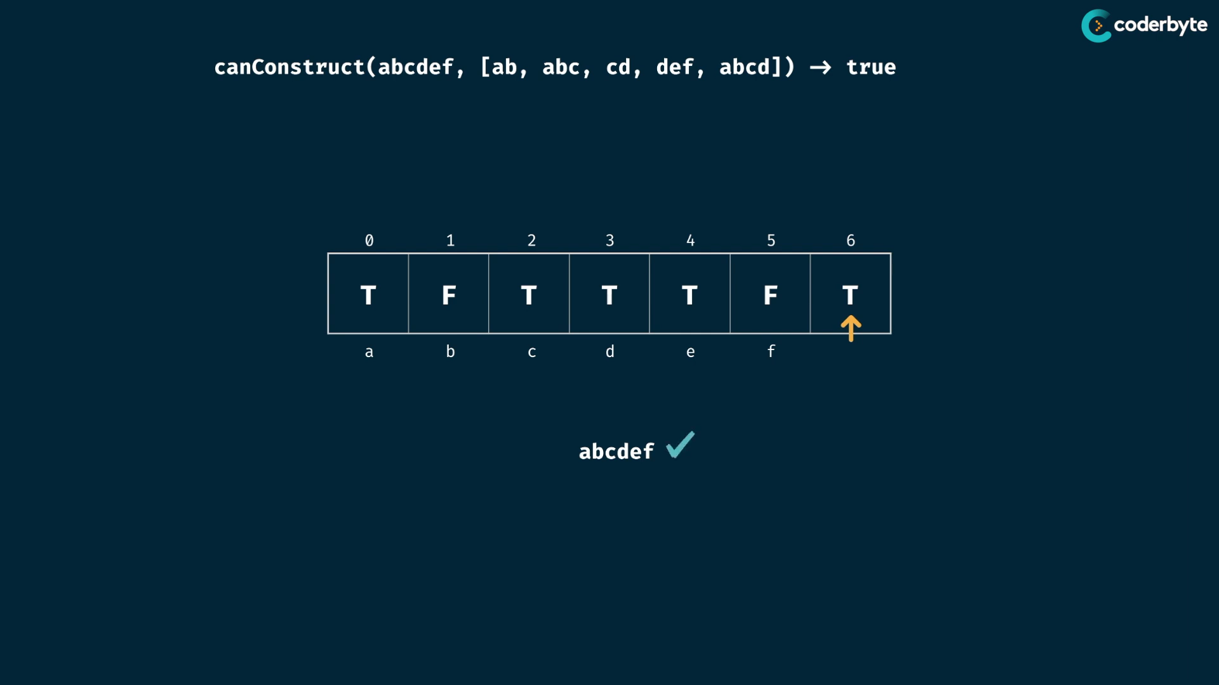

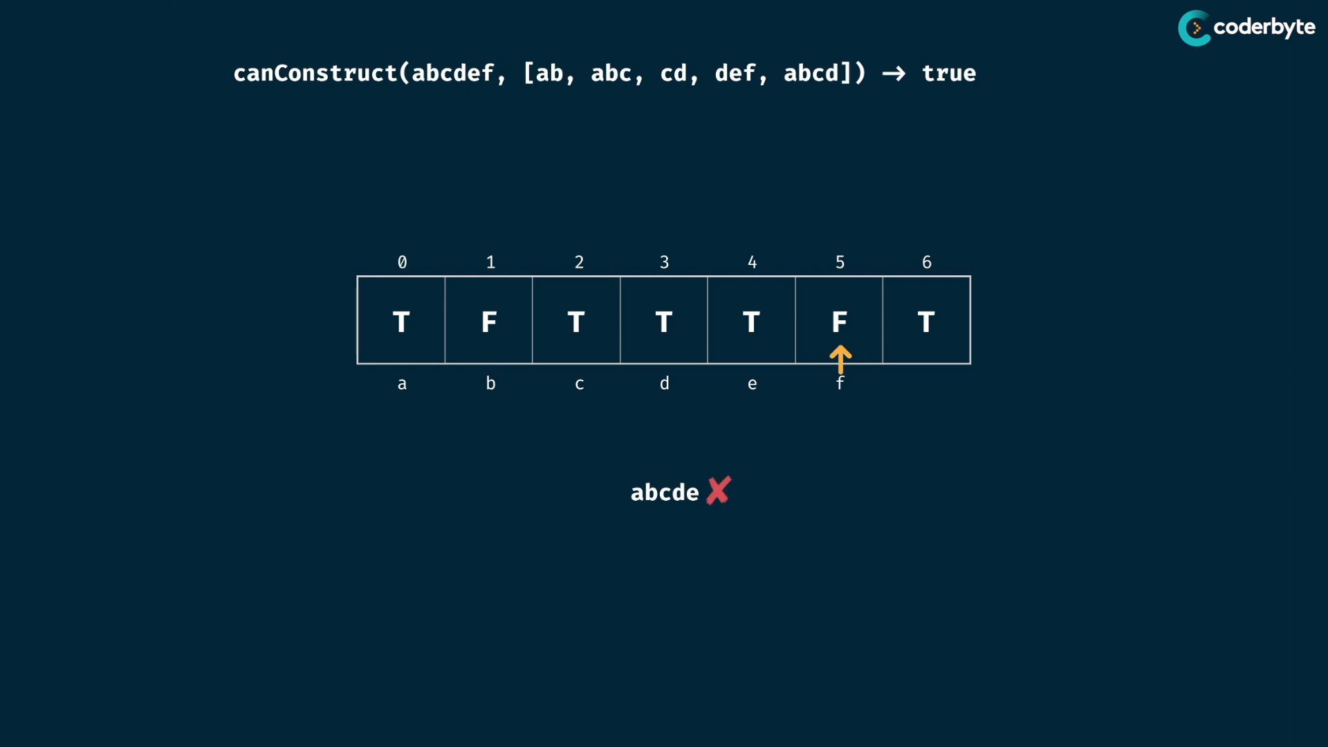

cmplx:

m = target string

n = words in wordBank

time :

* table size of m
* every element in table , we check all words of wordBank , so m* n
* at every word , we do character matching with words of wordBank , so its possible of word chars of m

so therefore O(m*n*m)

space:

* array of booleans , just m space

so O(m)

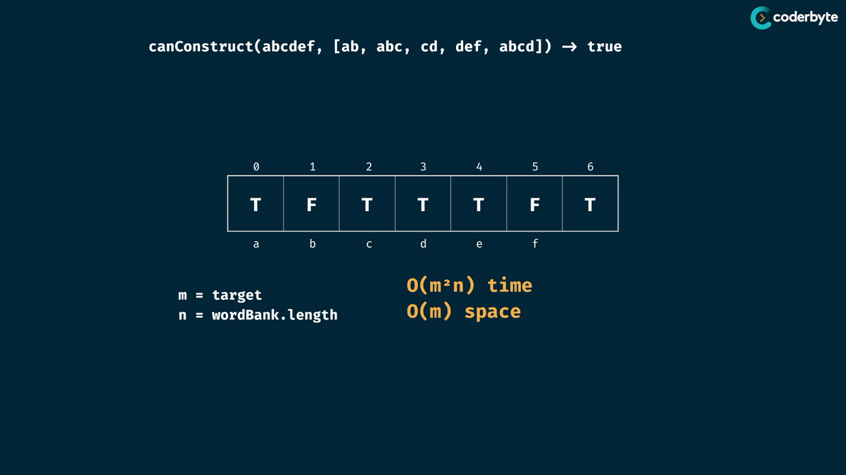

code :

const canConstruct = ( target, wordBank ) =>{

    let table = Array( target.length + 1).fill(false);

    table[0] = true;

    for(let i = 0; i < target.length; i++){

        if(table[i] === true)

            for( word of wordBank){

                if(target.slice(i).indexOf(word) === 0){

                    table[i+word.length] = true;

                }

            }

        }

    }

    return table[target.length];

}

console.log(canConstruct("abcdef",['ab','abc','cd','def','abcd']));     //=> true

console.log(canConstruct("skateboard",['bo','rd','ate','t','ska','sk','boar']));//=> false

console.log(canConstruct("enterapotentpot",['a','p','ent','enter','ot','o','t']));//=> true

console.log(canConstruct("eeeeeeeeeeeeeeeeeeeeeeeeeeeeeeeeeeeef",[

    'e',

    'ee',

    'eee',

    'eeee',

    'eeeee',

    'eeeeee',

    'eeeeeeee',

]))   //=> false

countConstruct:

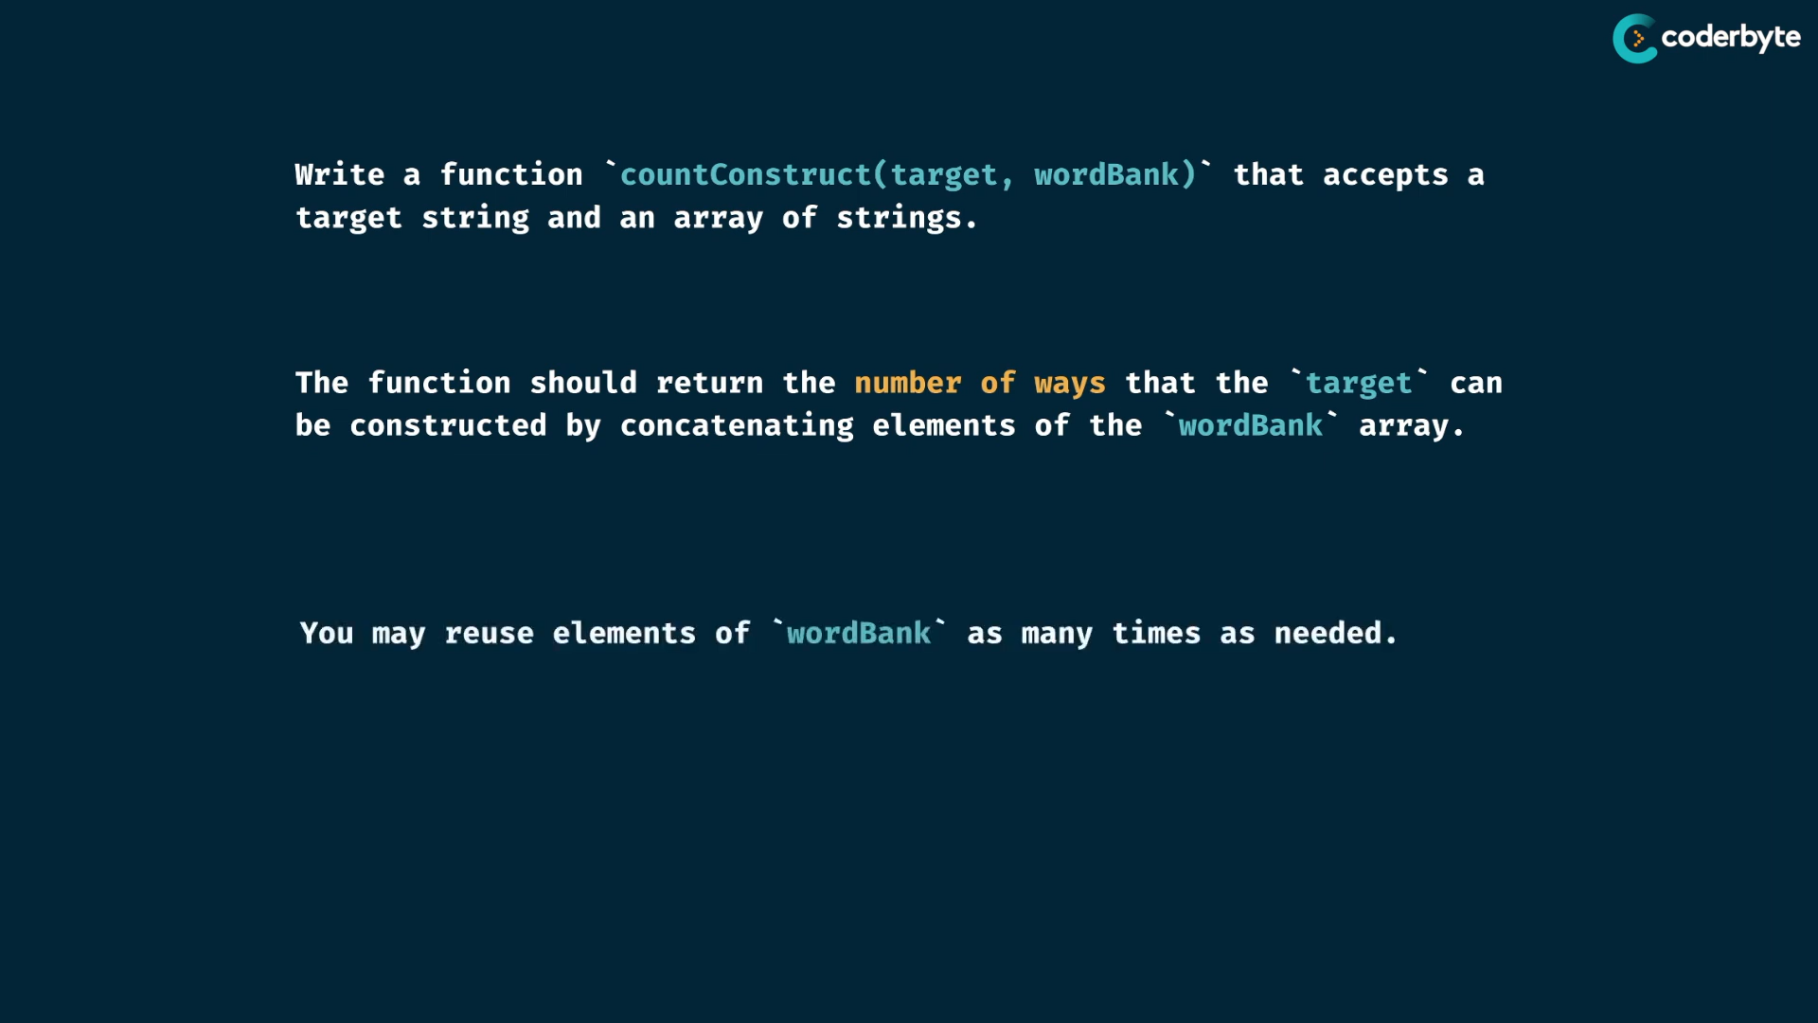

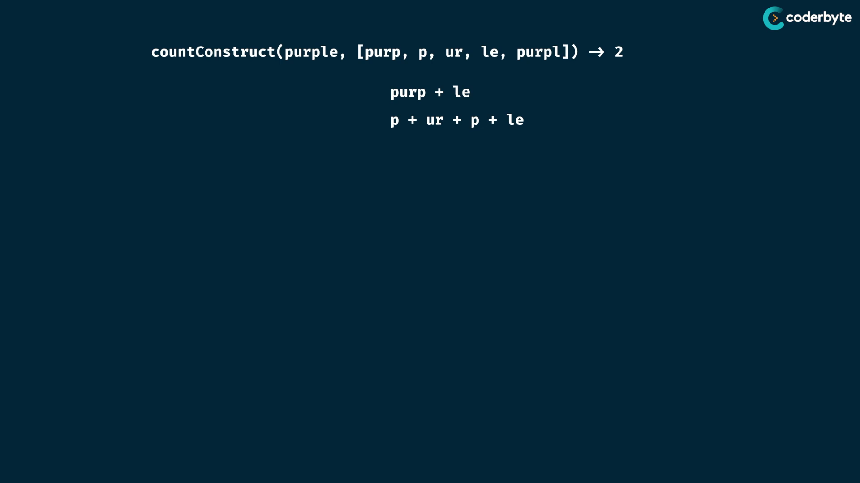

tab:

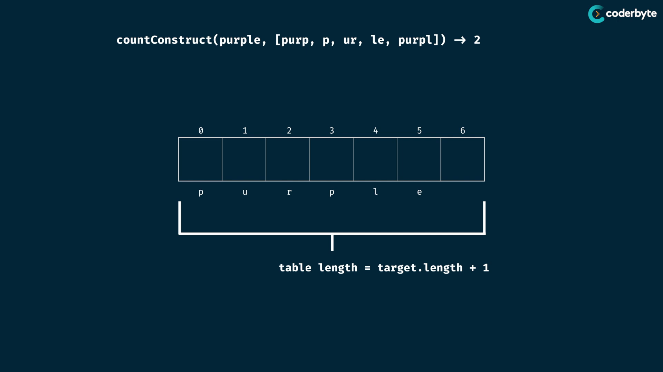

seed values

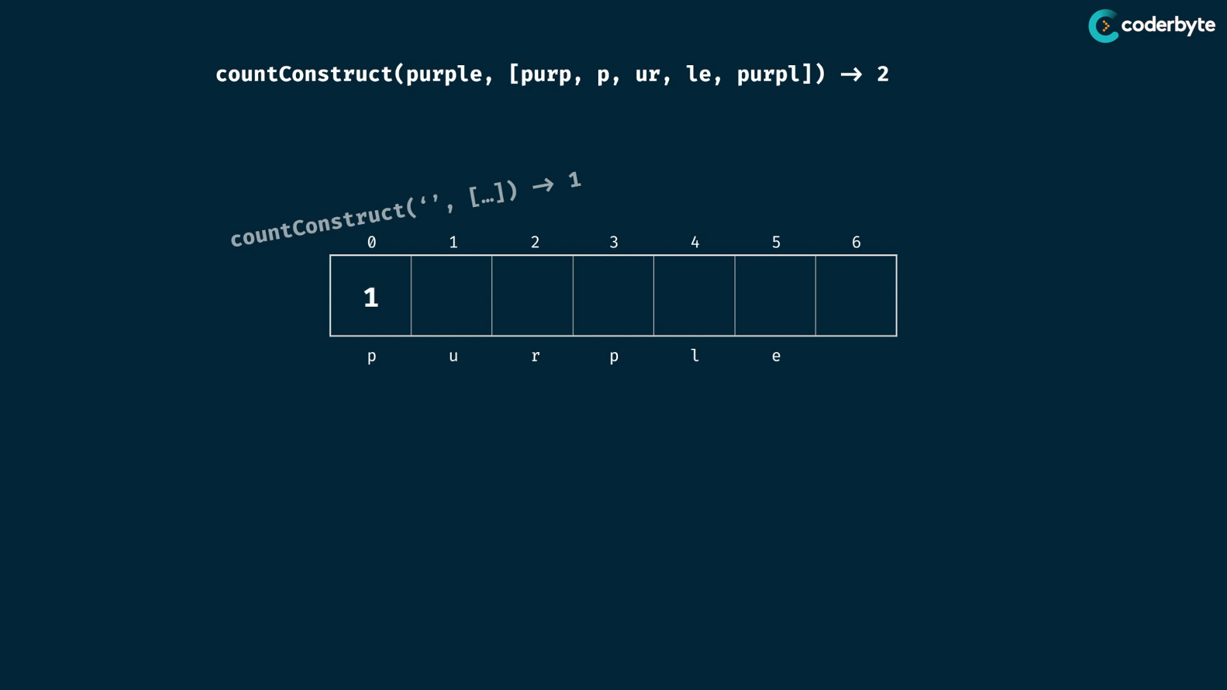

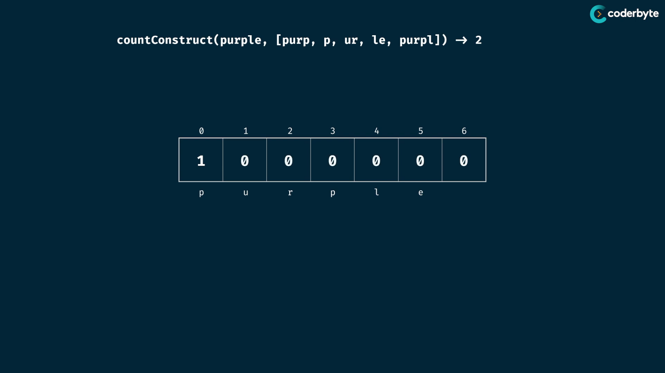

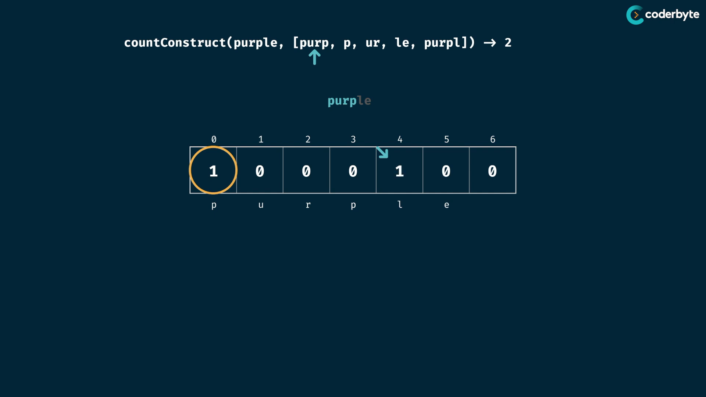

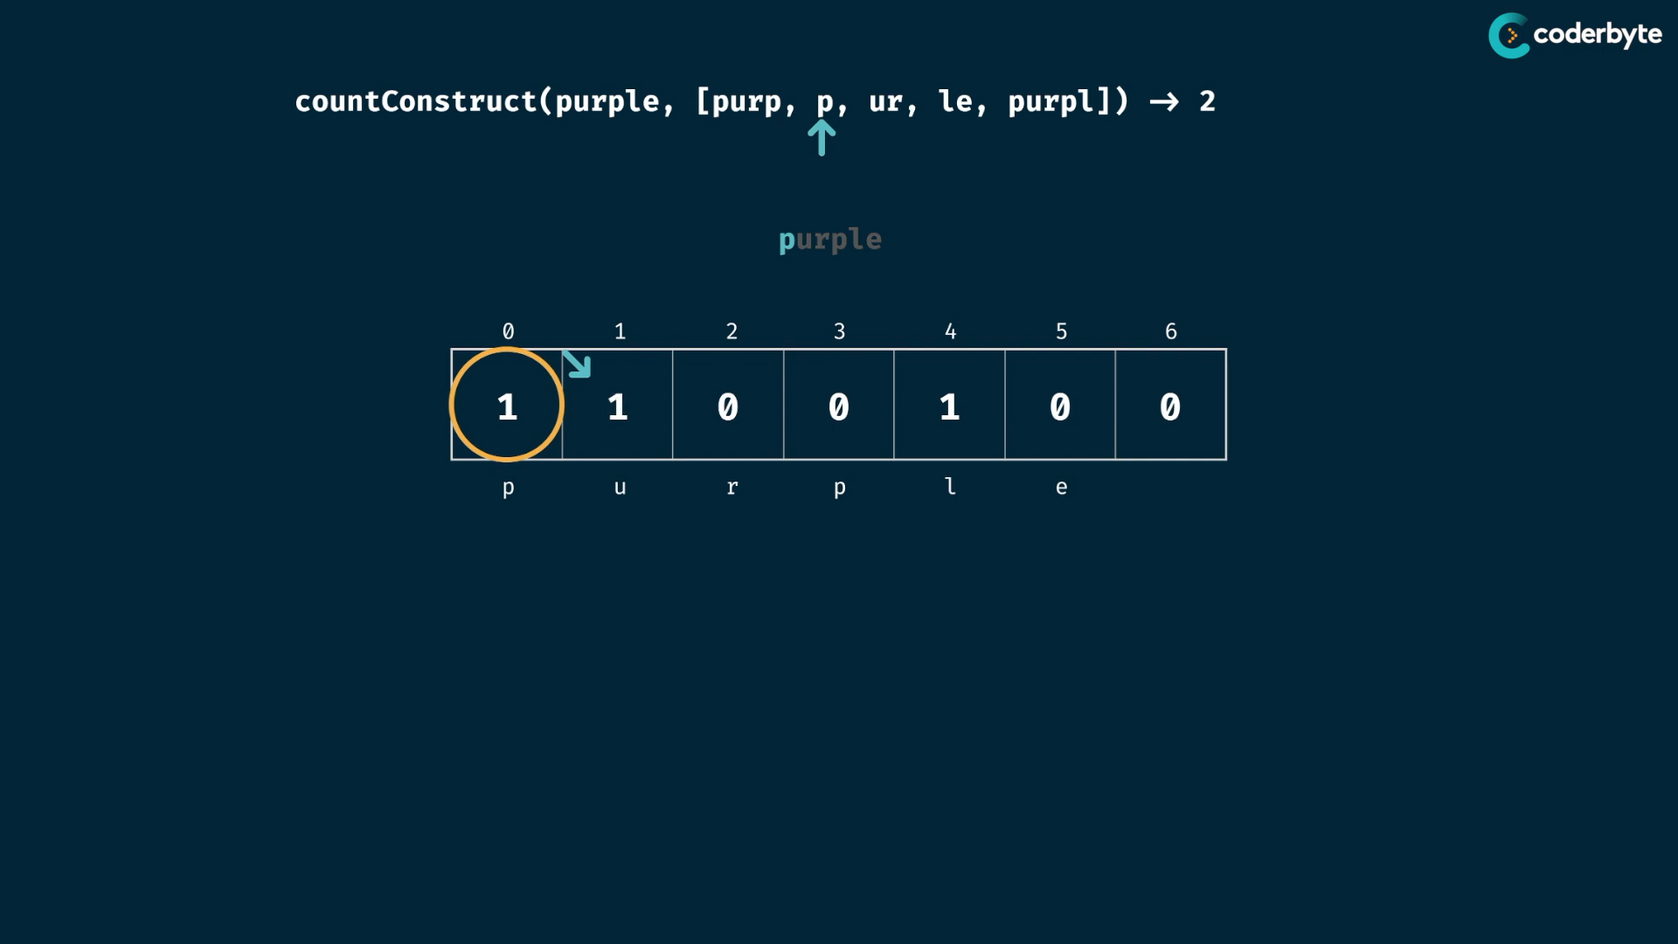

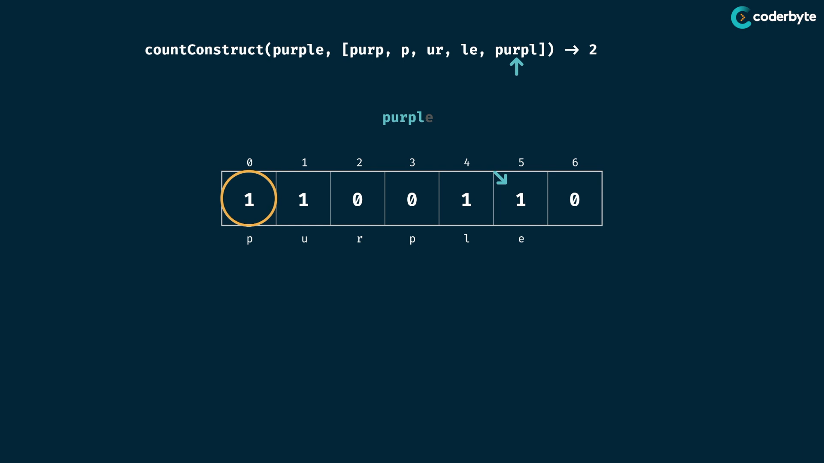

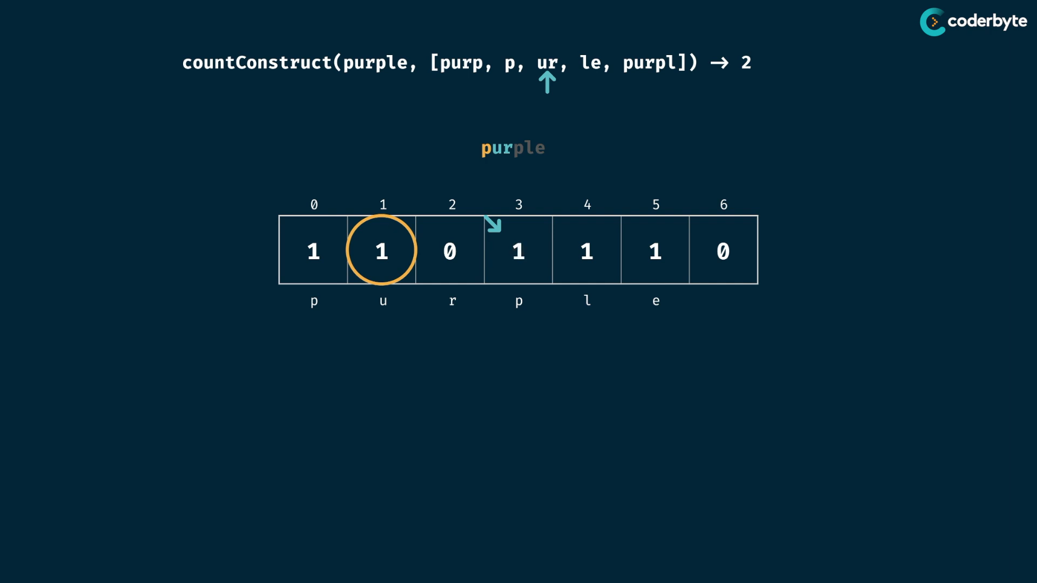

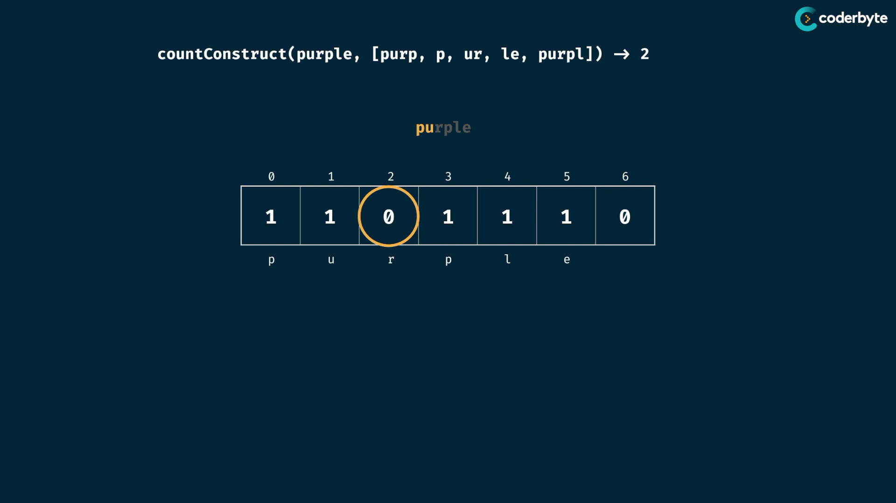

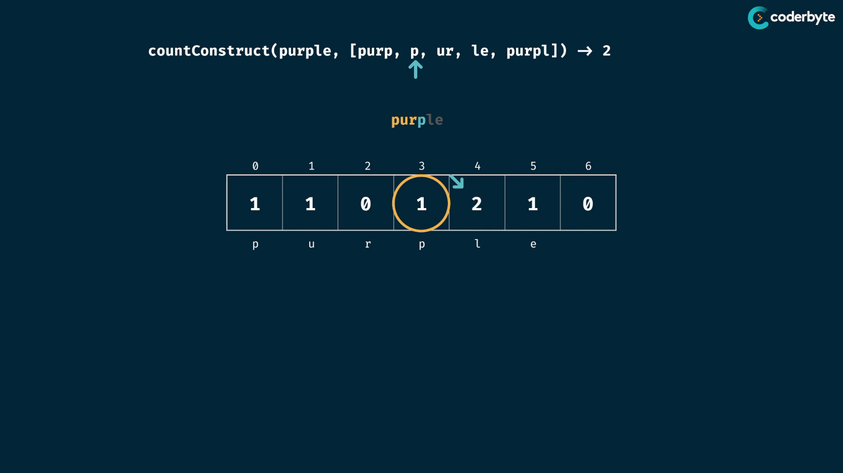

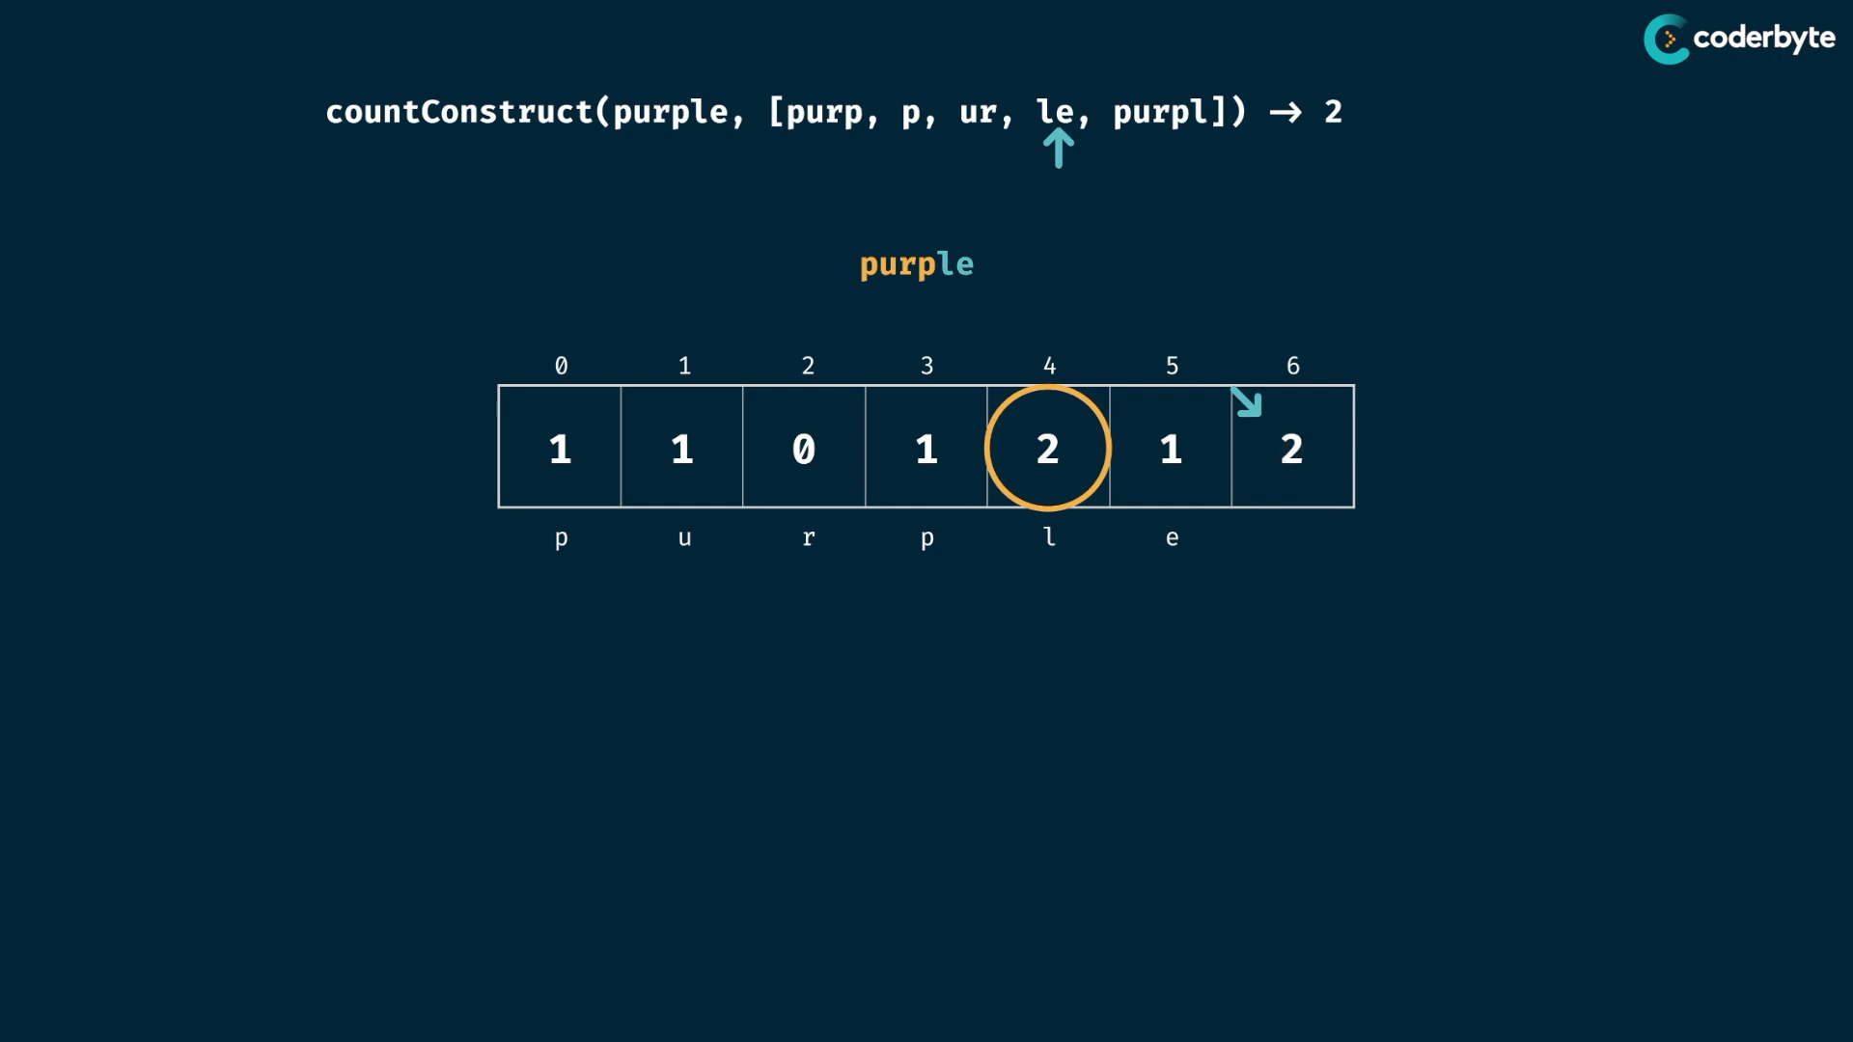

checking

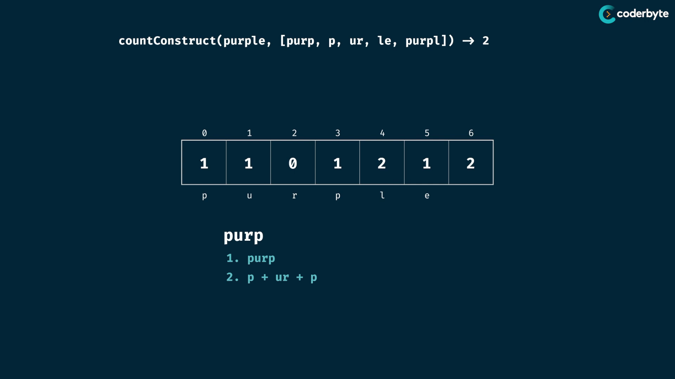

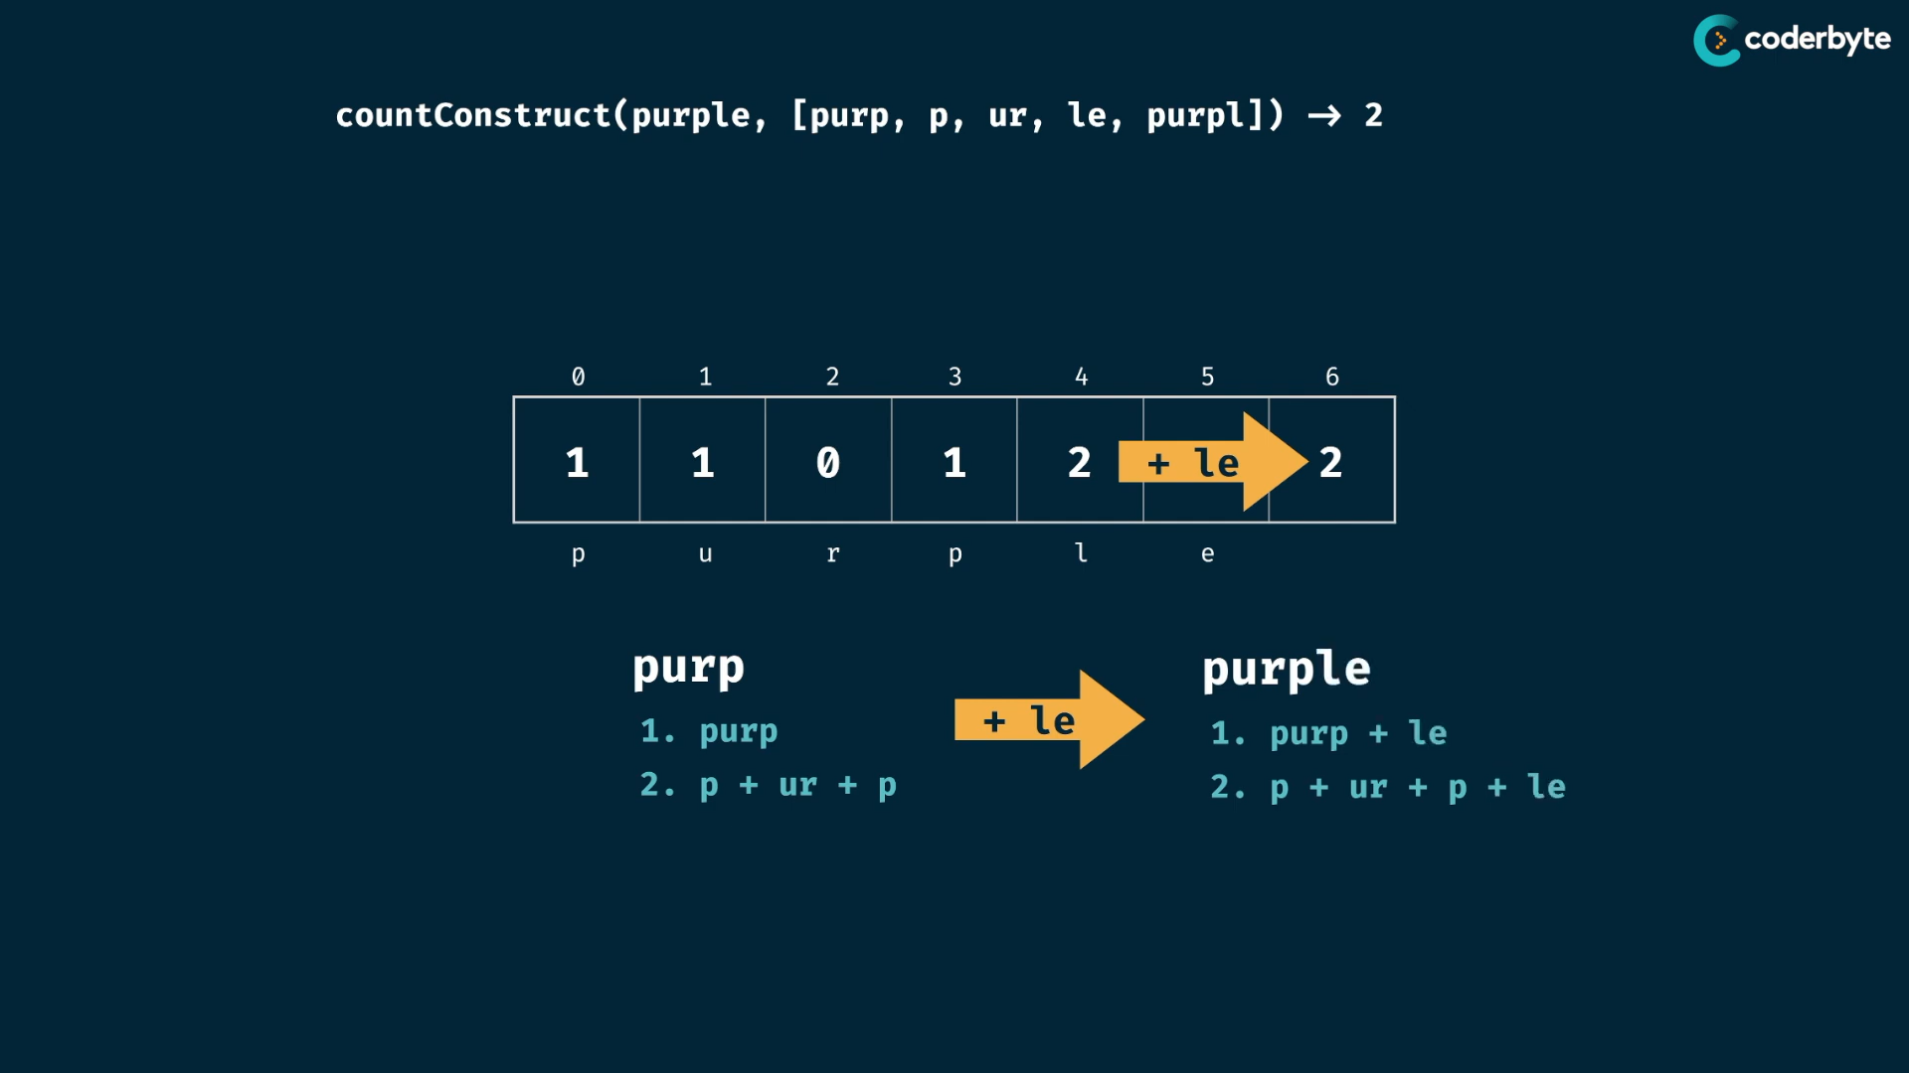

cmplx:

same cmplx like last , since last is boolean , now int as values in table

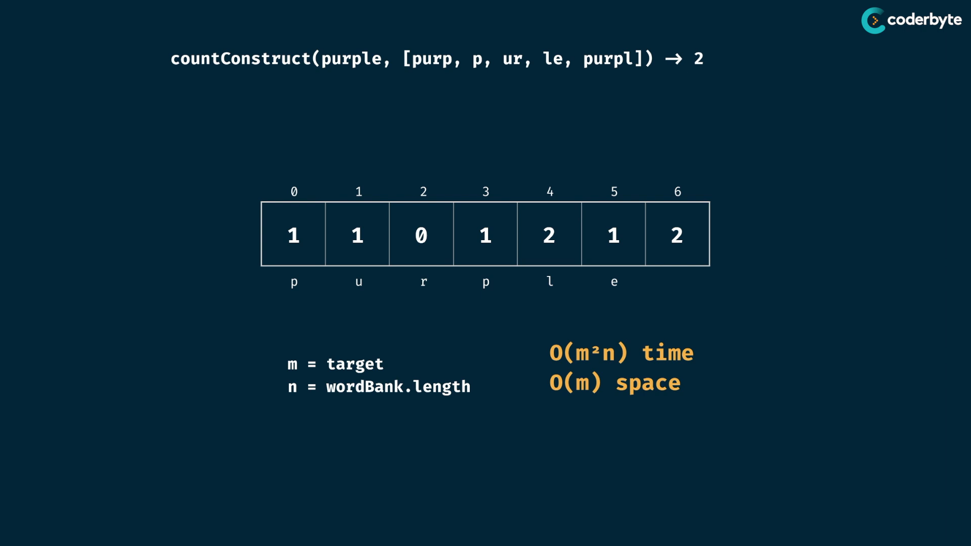

code:

//+ countConstruct (tab)

const countConstruct = (target,wordBank) => {

   let table = Array(target.length+1).fill(0);

   table[0] = 1;

   for(let i=0;i<target.length;i++){

      //if(table[i]>0) // no need this cond

      for(word of wordBank){

         if(target.slice(i,i+word.length) === word){

            table[i+word.length] += table[i];

         }

      }

   }

   return table[target.length];

}

console.log(countConstruct('purple',['purp','p','ur','le','purpl']))        //=> 2

console.log(countConstruct("abcdef",['ab','abc','cd','def','abcd']));     //=> 1

console.log(countConstruct("skateboard",['bo','rd','ate','t','ska','sk','boar']));//=> 0

console.log(countConstruct("enterapotentpot",['a','p','ent','enter','ot','o','t']));//=> 4

console.log(countConstruct("eeeeeeeeeeeeeeeeeeeeeeeeeeeeeeeeeeeef",[

   'e',

   'ee',

   'eee',

   'eeee',

   'eeeee',

   'eeeeee',

   'eeeeeeee',

]))   //=> 0

allConstruct problem:

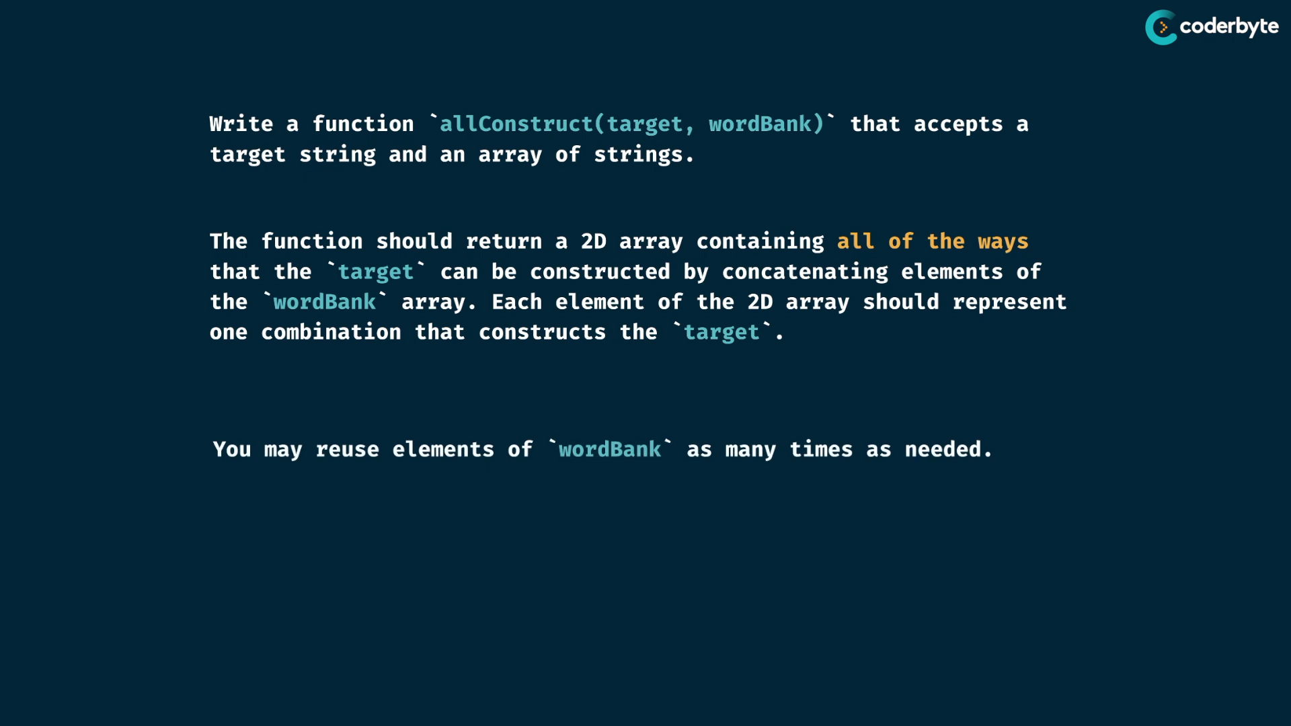

exp:

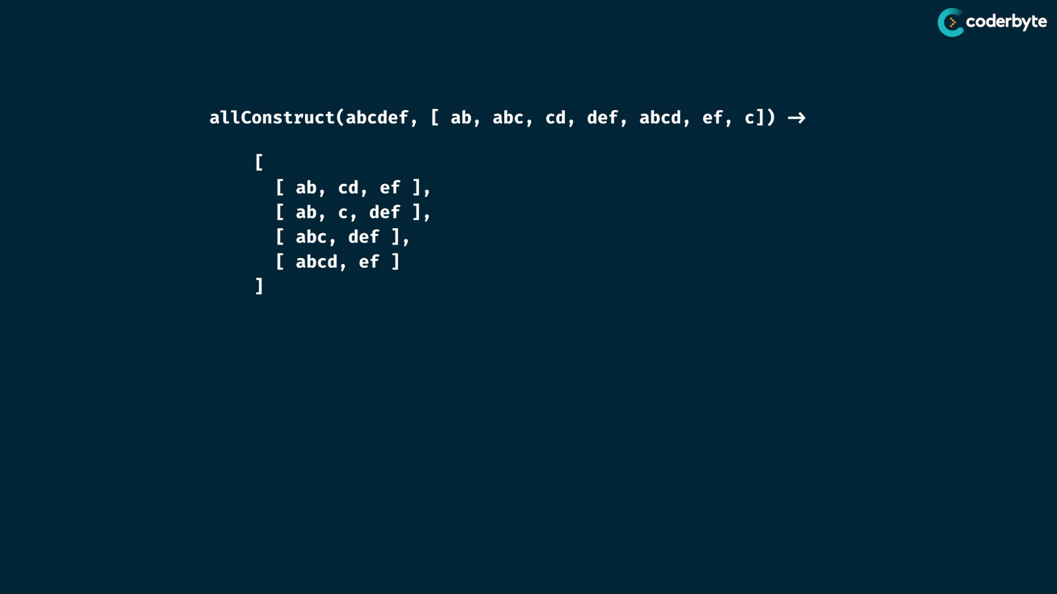

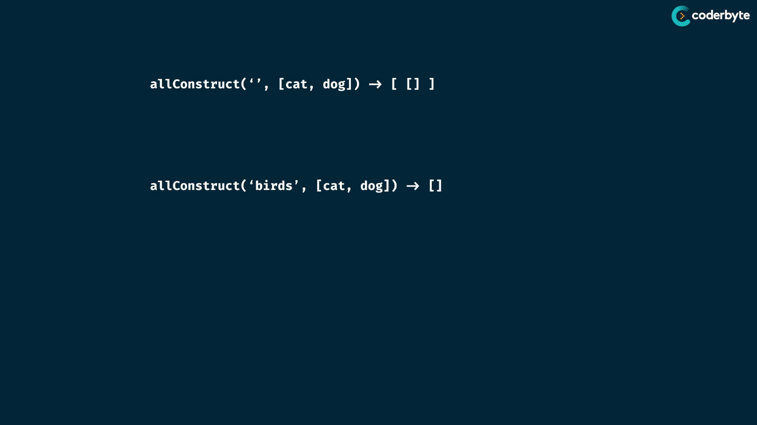

solving:

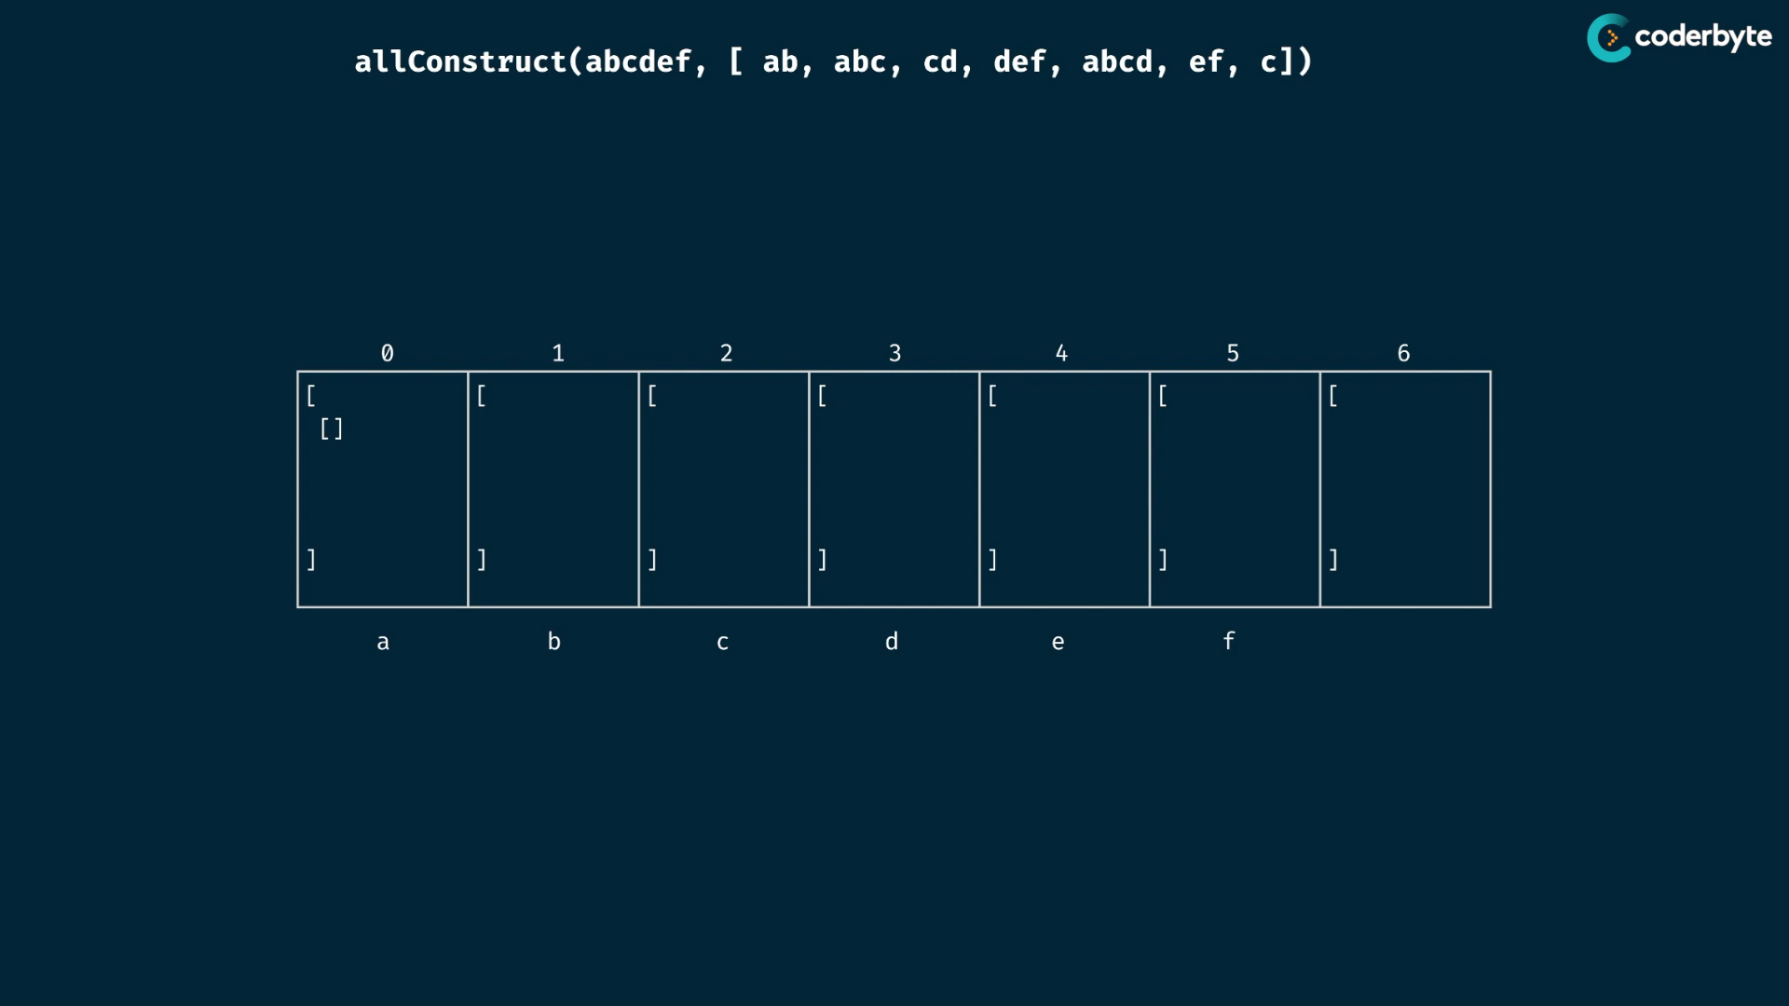

solve:

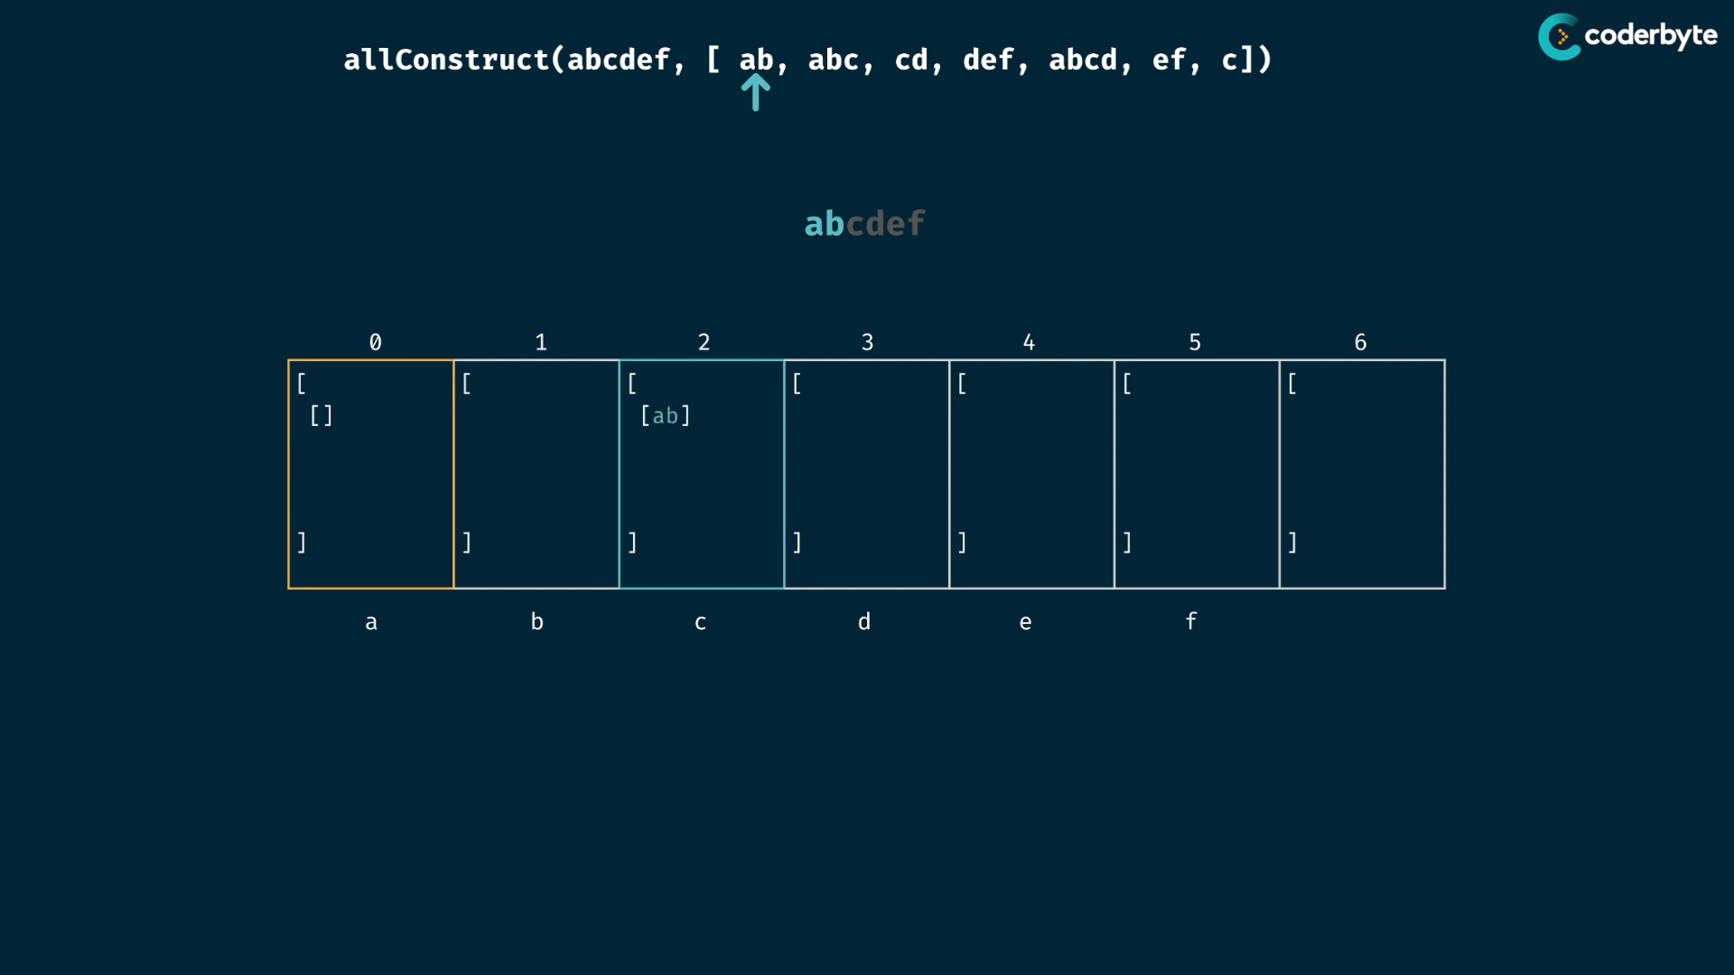

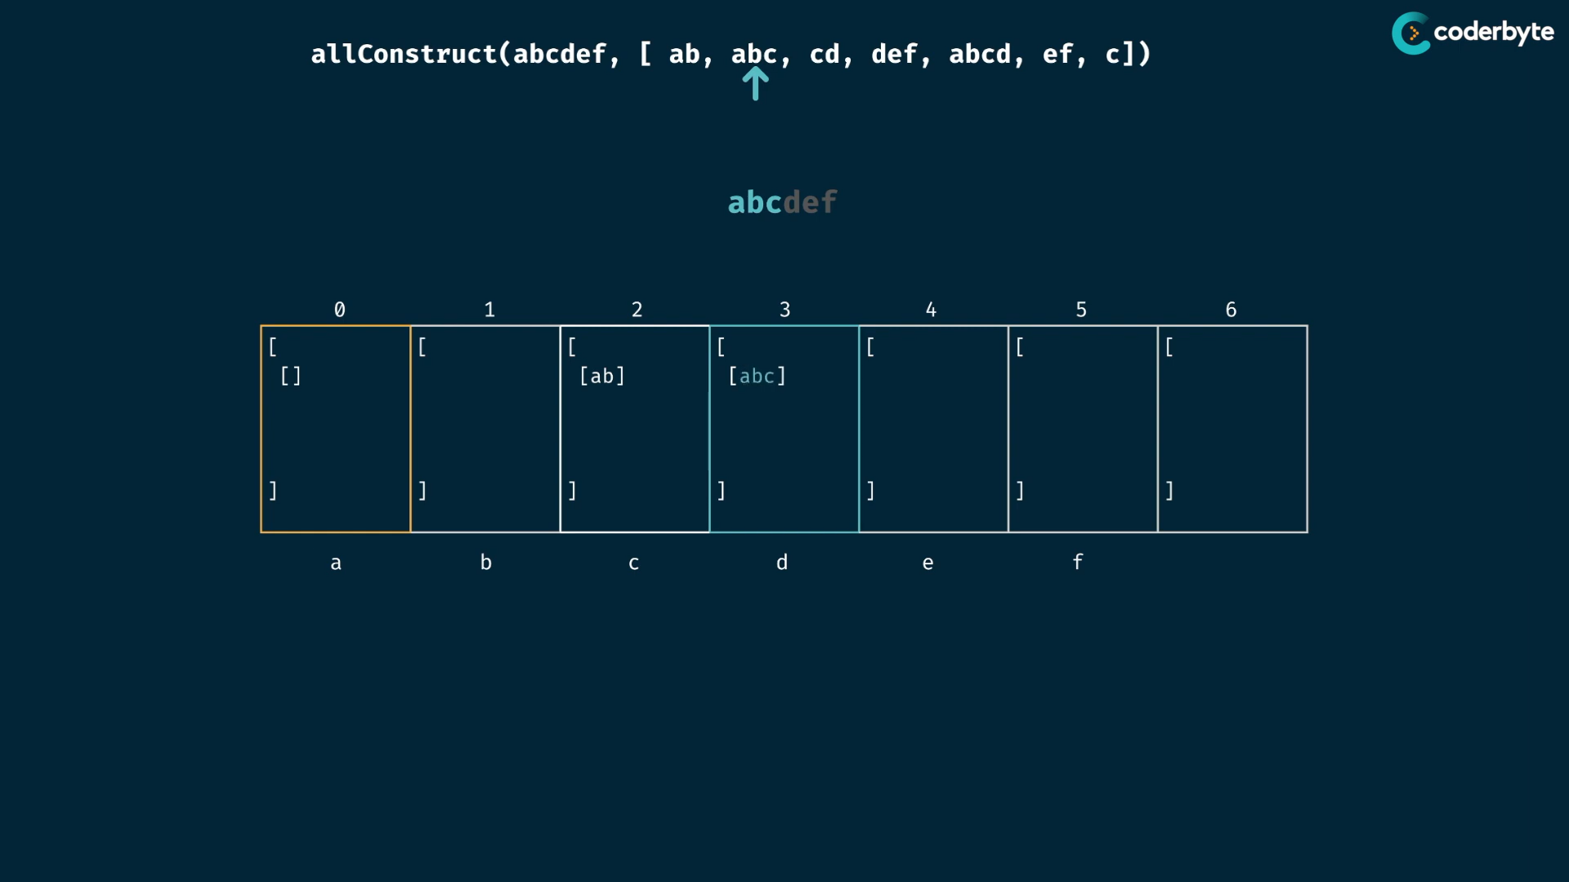

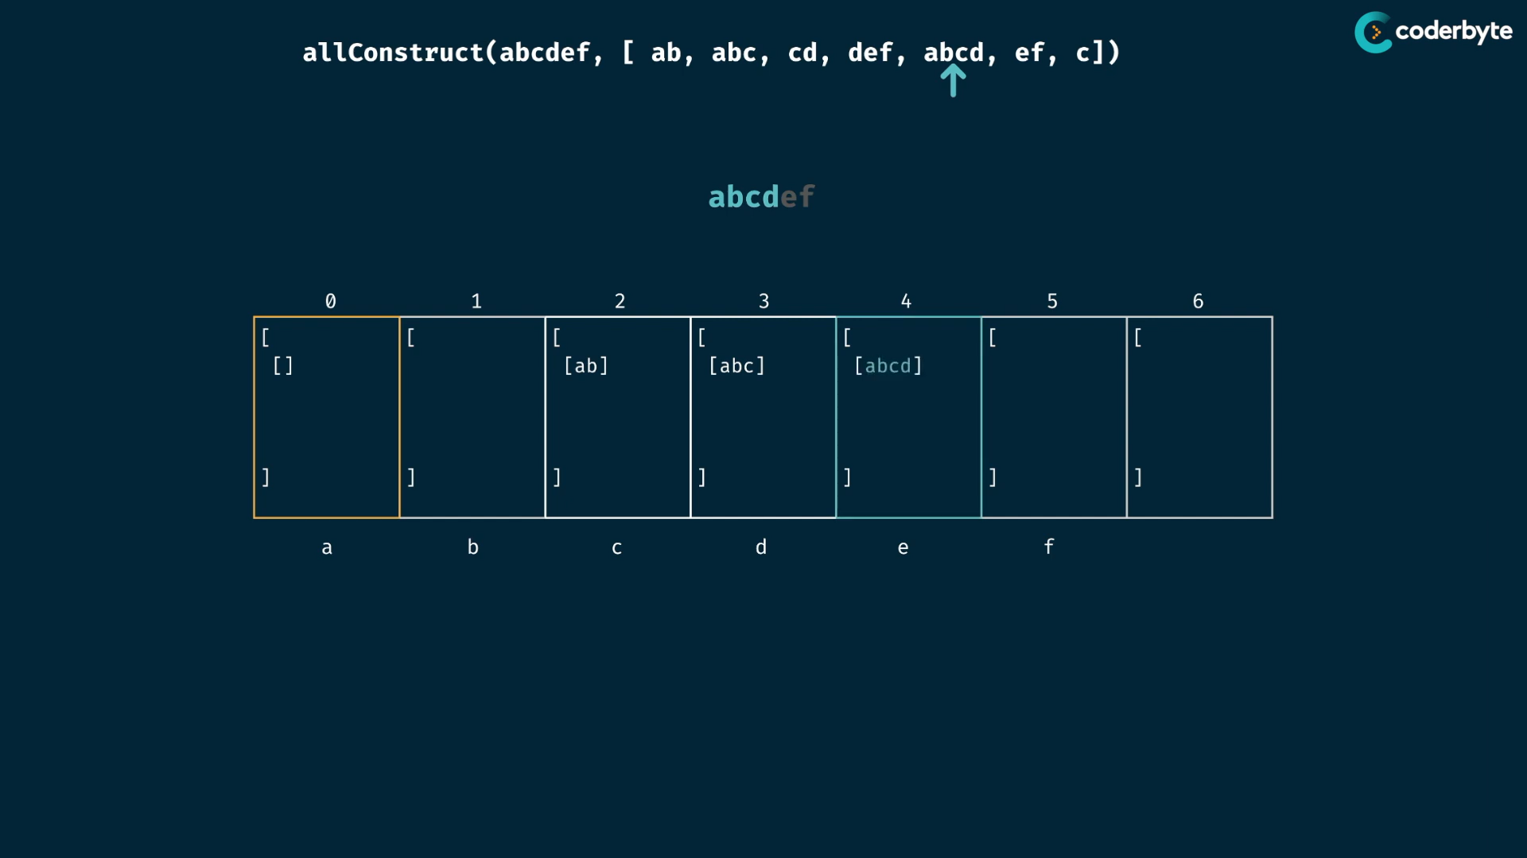

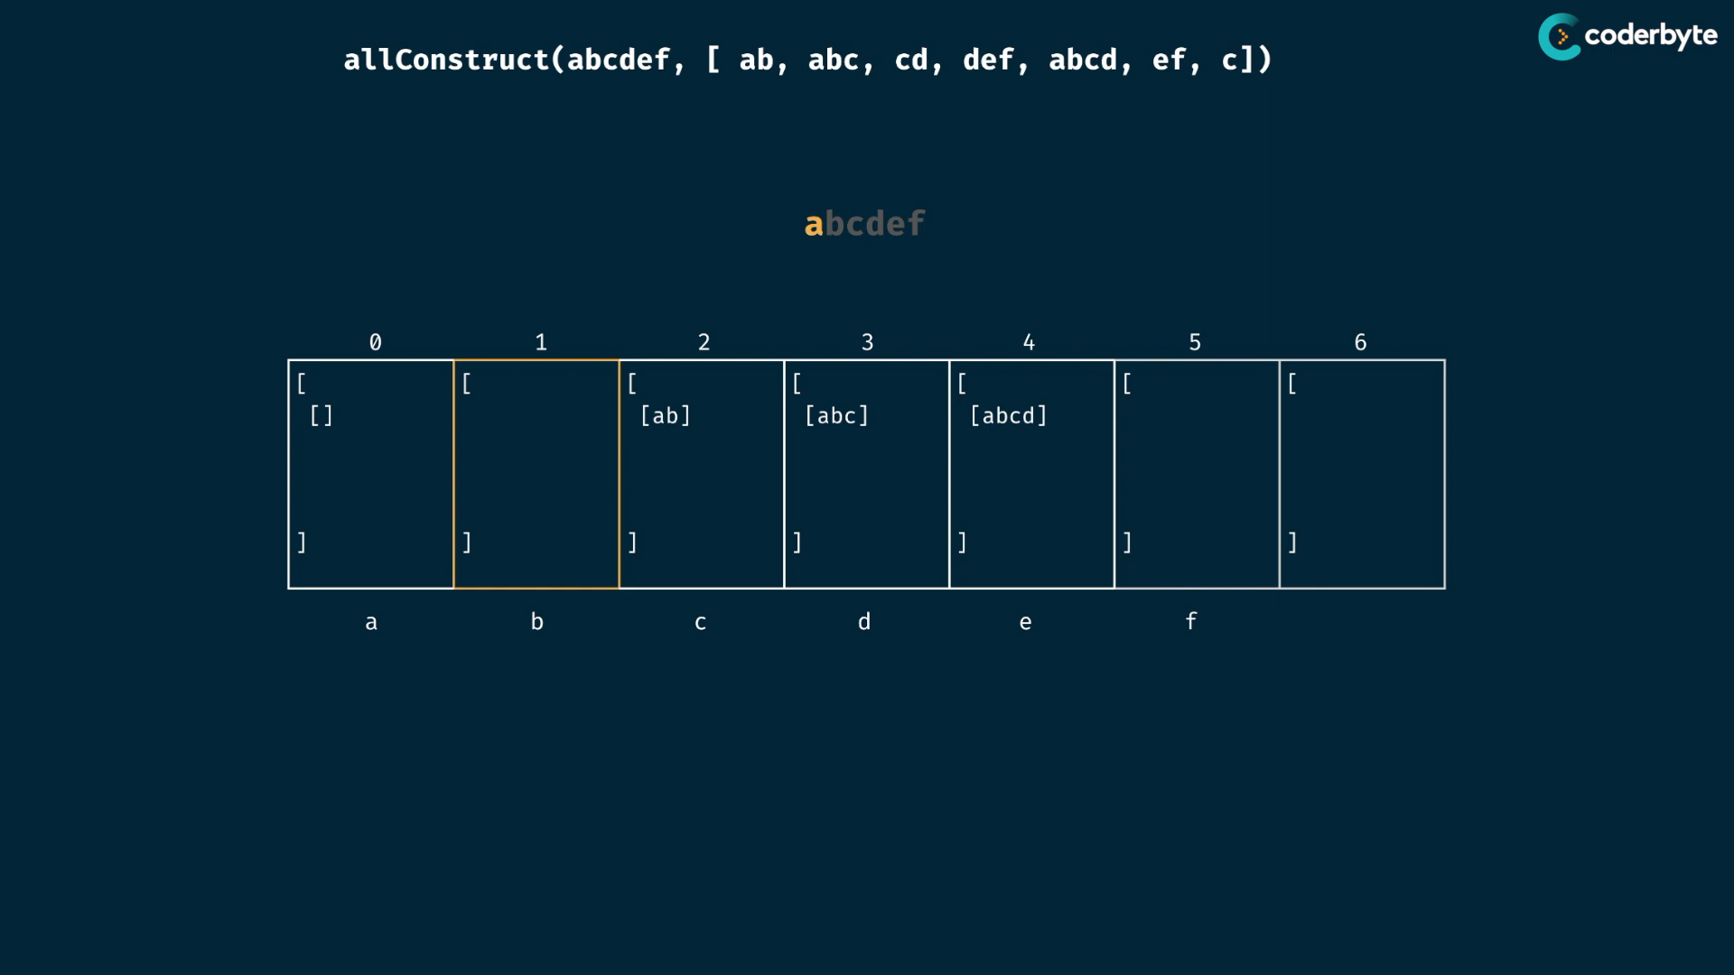

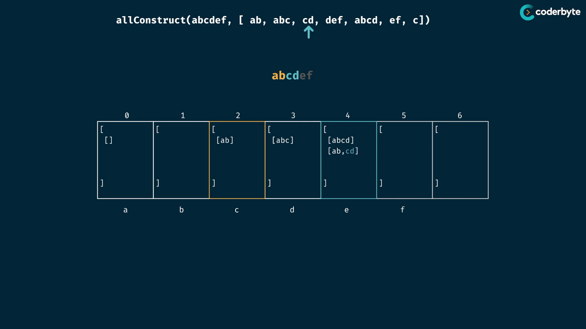

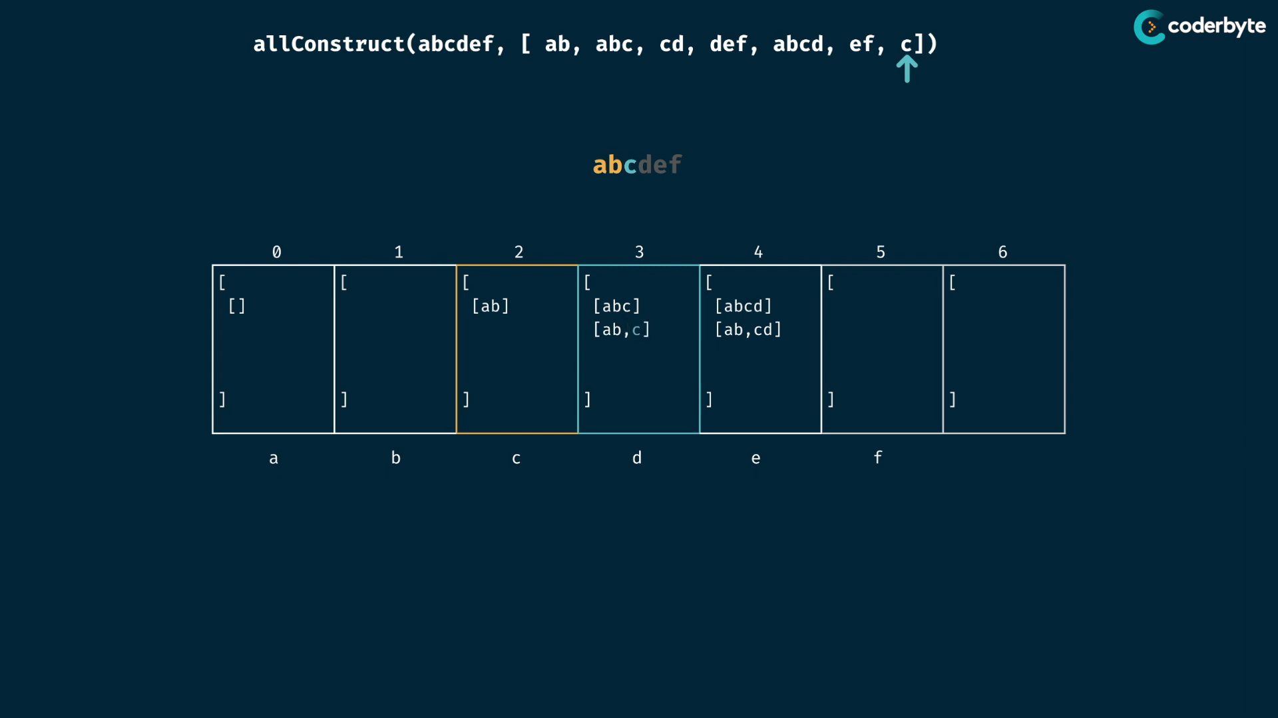

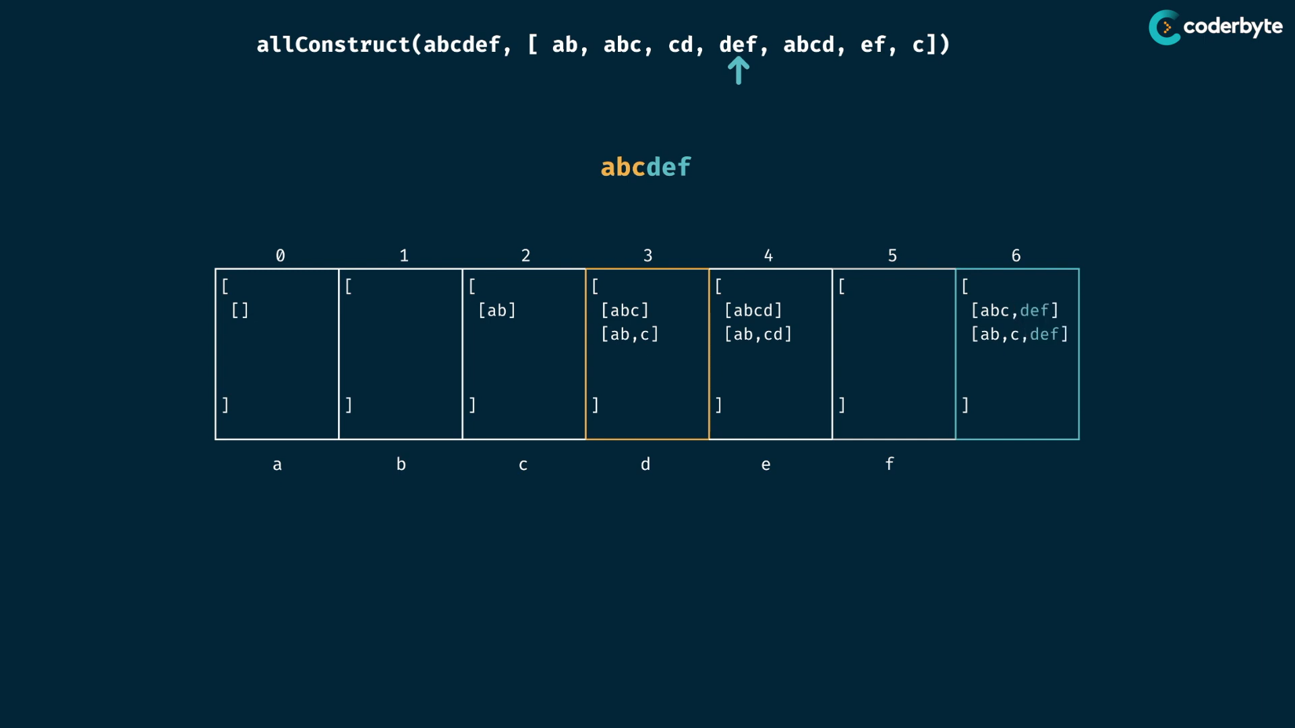

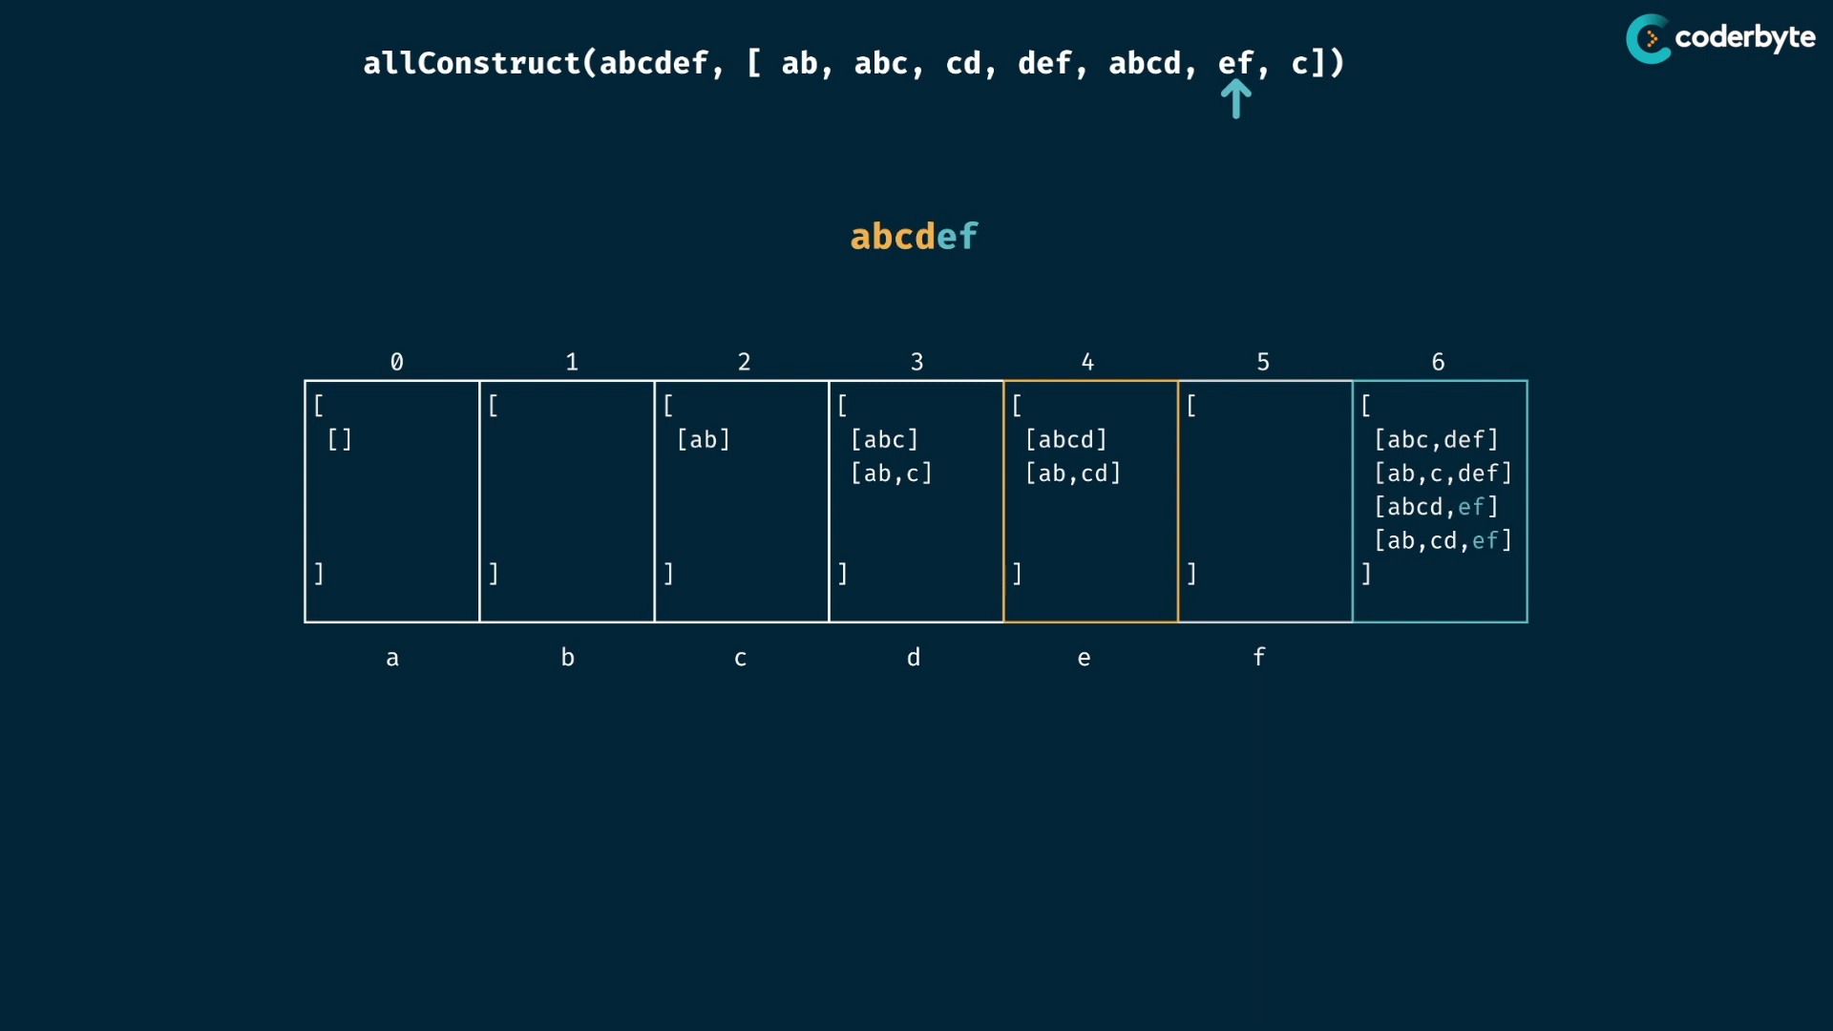

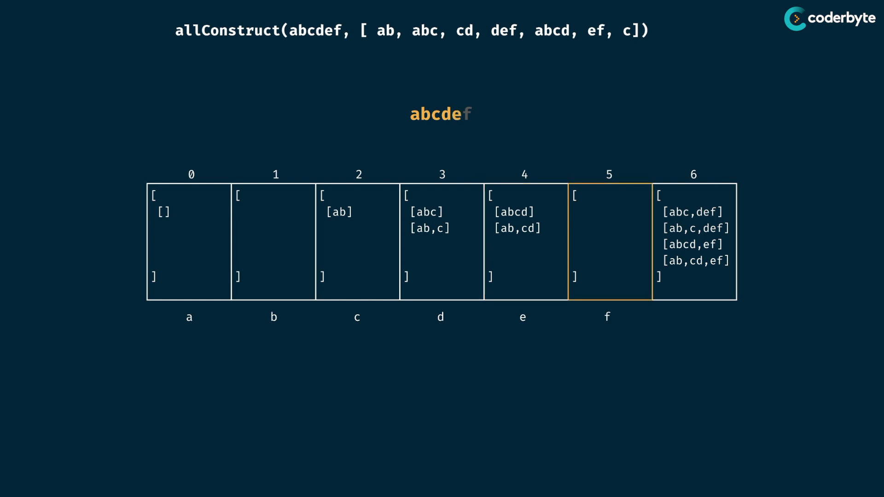

cmplx:

m = target.length

n = wordBank.length

time:

O(n^m * m_little etc..) -> each target length n has m sub arrays at worst case..

exponential combinations..

space:

each table of m length have n wordbank of m sizes.. like 3d table…

any particular table have exponential things .. O(m _little* n^m)

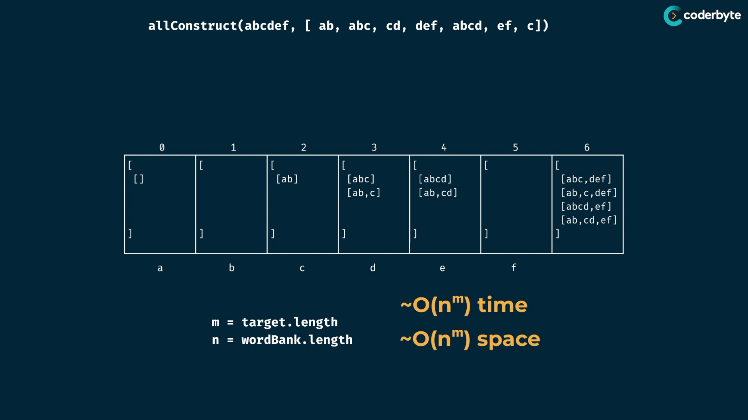

so atlast we end up with exponential cmplx..

code:

//+ allConstruct (tab)

const allConstruct = (target,wordBank) => {

   let table = Array(target.length +1)

               .fill()

               .map(

                   () => []

               );

   table[0] = [[]];

   for(let i=0;i<target.length;i++){

      for(let word of wordBank){

         if(target.slice(i).indexOf(word)===0){

            const newCombinations = table[i].map(subArray => [...subArray,word]);

            table[i+word.length].push(...newCombinations);

         }

      }

   }

   return table[target.length];

};

console.log(allConstruct('purple',['purp','p','ur','le','purp']));

/*

[

   [ 'purp', 'le' ],

   [ 'purp', 'le' ],

   [ 'p', 'ur', 'p', 'le' ]

]

*/

console.log(allConstruct('abcdef',['ab','abc','cd','def','abcd','ef','c']));

/*

[

 [ 'abc', 'def' ],

 [ 'ab', 'c', 'def' ],

 [ 'abcd', 'ef' ],

 [ 'ab', 'cd', 'ef' ]

]

*/

console.log(allConstruct('skateboard',['bo','rd','ate','t','ska','sk','boar']));

/*

[]

*/

console.log(allConstruct('aaaaaaaaaaaaaaaa',['a','aa','aaa','aaaa','aaaaa']))

/*

[

 [

   'a', 'a', 'a', 'a',

   'a', 'a', 'a', 'a',

   'a', 'a', 'a', 'a',

   'a', 'a', 'a', 'a'

 ],

 [

   'a', 'a', 'a',  'a',

   'a', 'a', 'a',  'a',

   'a', 'a', 'a',  'a',

   'a', 'a', 'aa'

 ],

 ... 26684 more items

]

*/

//console.log(allConstruct('aaaaaaaaaaaaaaaaaaaaaaaaaz',['a','aa','aaa','aaaa','aaaaa']))

// but this input worked in memoization...

/*

RangeError: Maximum call stack size exceeded

*/

console.log(allConstruct('aaaaaaaaaaaaz',['a','aa','aaa','aaaa','aaaaa']))

/*

[]

*/